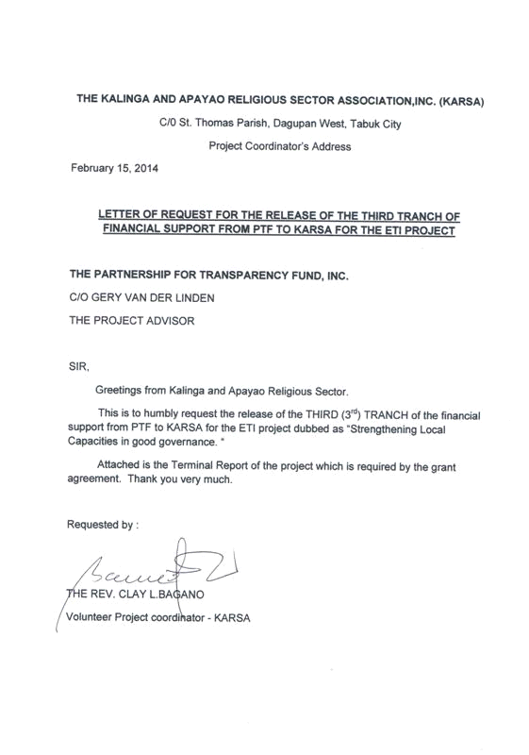

KARSA TERMINAL REPORT
ON
STRENGTHENING LOCAL CAPACITIES IN GOOD GOVERNACE

- BACKGROUND OF THE PROJECT AND ITS OBJECTIVES
In line with its advocacy on good governance, the Kalinga Apayao Religious Sector Association embarked on a one year project on “Strengthening Local Capacities in Good Governance.”
This project aimed to:
- Facilitate access to justice and governance reforms, and strive to work at the community level particularly, to support them in practically operationalizing the principles of good governance, transparency and accountability, by supporting them in identifying weaknesses, and working with them to build stronger governance frameworks and improve their local democratic structures to enable more efficient running and management of their local authorities and resources to facilitate local economic development.
- The project shall help the local populace and barangay officials to understand the principles of effective local democracy and good governance and how this relates to local accountability. It will explore practical solutions for developing robust structures as tools to improve local accountability and decision making, and suggest initiatives and projects to help foster and support local democracy within the community.
- To deepen local democracy to ensure that the local bodies are truly accountable and responsible to the communities that they serve,
- To build stronger and more effective intergovernmental relations. With the principle that Citizen’s priority needs are better addressed and given attention when solutions are actually based on them. Government should be able to design programs and projects when they are able to draw inputs from the citizens and these are carried out through increased citizen’s participation.
- To have a greater access to and participation of citizens in local decision making. To have an access to the public documents like budget, plans and program of works and getting involve in public hearings and dialogues is a hard task for citizens without linkages and networks, thus they are empowered through collaboration with other partners to increase citizens participation.
- Improved accountability and transparency, including openness to scrutiny & inclusiveness in decision making.

- PARTNERS IN IMPLEMENTATION
This project was made successful through the financial and technical support from the Partner for Transparency Fund (PTF) and the Affiliated Network for Social Accountability-East Asia and the Pacific(ANSA-EAP). This is in accordance to the grant agreement between KARSA with PTF and ANSA-EAP which states:
“Kalinga Apayao Religious Sector Association (KARSA) has requested financial support of The Partnership for Transparency Fund, Inc. (PTF) to implement a program for promoting understanding and practice of participatory democracy and good governance in target barangays in Tabuk City, Kalinga. The program will be called “Strengthening Local Capacities in Good Governance” and will commence from 01 February 2013.”

It can not also be denied that the Northern Luzon Coalition for Good governance(NLCGG) where KARSA is also a member was and is, of great help to access the external support stated above. The Local Government from the City to the provincial level were also instrumental and very inspirational to the initiatives of the implementer by being supportive in terms of documents needed and accreditations and memorandum of understanding with KARSA.

3. THE PROJECT LOCATION
Originally the approved proposal limits the financial capacity to only three(3) barangays in Tabuk City but due the fact that KARSA had an earlier engagement on Social Accountability(Sac) with at least five(5) Barangays, it decided to stretched out the fund to at least cover all the five Barangays namely: Balong, Laya West, Casigayan, Dagupan West, and Magsaysay all in Tabuk City. Lately in the last quarter of 2013, it expanded to include Baraga San Juan, Tabuk City. Making the total coverage to at least six(6) Barangays. It must be noted that the duration of engagement with these barangays started last February 2013 when the first release of the fund from PTF was disbursed to KARSA. So practically it is one year.

4. PRELIMINARY ACTIVITIES
Before the actual engagement with the Barangays on matters relative to the activity line of this program namely Accountability, Transparency, and Participatory governance, the following were undertaken first to lay the foundation of the engagement:
- Made an audience with the City Mayor Ferdinand Tubban, and the City DILG Julio Barcellano, seeking their blessing and support for the planned good governance partnership with 5 barangays in the City,
- Get fresh mandate of partnership with the five(5) Barangays by entering into an MOU with the local council.
- Conducted an inception workshop through the help of ANSA-EAP represented by Mr. Randee Cabacas, and from the Makati Busines Club represented by Edward Gacusana at the Golden Berries Hotel, Tabuk City. Representatives of the local officials and citizens from 5 Barangays were gathered to discuss concepts, methods, and approaches for the implementation of the program.
- Gathered more informations via social investigation and consultations about the concerns and interests of the Barangays in order to tailor fit methodologies to be used.

5. METHODOLOGY USED FOR THE PROJECT
In order to maximise the time of the concerned officials and volunteer citizens in the barangay, some activities were done in the barangays individually, while some were done jointly in a single venue where all the five barangay representative were invited.
Many of the engagement were done through barangay visitations, with the local officials during their sessions and meetings, formal consultations and informal coffee sessions with the purok leaders and elders. House to house visitations were also employed in some barangays, Pulpit information's and church gatherings were very helpful in molding insights for active and inspired collective action for participation and involvement as well as advocacy activities. Bulk of the activities were trainings, and seminars which includes lectures, presentations, workshops, and sharing of experiences that encouraged each participant to get involved and express insights.
Related group dynamics, buzz groups and role plays, working groups, reflection sessions and Bible studies were also introduced that allowed participants to internalize and inwardly digest what they learn.
Involvement of the concerned government officials and agency representatives in the program is also helpful for a maximum participation of the barangay officials. The mere presence of the City Mayor even just to grace the program inspired full and active support from the local Barangay . The presence of the DILG Oficer and the City Planning and Development officer and the City Election officer as part of the resource persons in some activities like seminar, planning or workshop programs also increased participation from the concerned barangay.
Actual planning and budgeting workshop with the barnagay officials and the BMTs were also done in the third quarter of the year.

5.1. SAMPLE OF SEMINAR INVITATION AND PROGRAM USED
KALINGA AND APAYAO RELIGIOUS SECTOR ASSOCIATION, INC.
UCCP, Magsaysay, Tabuk City
Kalinga Province
August 28, 2013
_______________________________________
_______________________________________
_______________________________________
Greetings …..
The Kalinga and Apayao Religious sector Association, Inc.(KARSA) in Partnership with the Northern Luzon Coalition for Good Governance(NLCGG), The Affiliated Network for Social Acountability- East Asia and the Pacific (ANSA-EAP), The Partnership for transparency International(PTI) with the Makati Business Club, wish to invite you for a one day seminar on Good Governance on September 5, 2013, 8:00 A.M. to 4:00P.M. at the Brgy hall, Balong, Tabuk City.
The objective of the seminar will be to: a. continuously help in giving education to the partner barangays on transparency and accountability issues, b. encourage different sectors within the Barangay to assist and help barangay officials or to contribute whatever they can towards good governance by vigilantly participating in the barangay planning & budgeting , c. organizing sectoral efforts to be in harmonize with and contributory to the Barangay budget & development plans .
The program shall be distributed upon registration at the venue. You are given a maximum of 30 participants from your barangay to attend this said seminar. Don’t forget to bring with you your smile and happiness, see you there.

PTR. LUIS AO-AS FR. CLAUDIO BAGANO
Chairman- KARSA Program Coordinator

5.2 THE KALINGA APAYAO RELIGIOUS SECTOR ASSOCIATION (KARSA)
THE PROGRAME
TIME | Module/Activity | Resource Person
AM SESSION  7:31 to 8:00 | Arrival & Registration of Participants | Secretariat
8:01 to 8:30 | Opening Rituals  - Opening Prayer  - Welcome Remark  - Introduction of Participant and setting of expectations  - Key note Address  - Presentation of Training Objectives and Flow | -ECW Rep.  - Brgy. Capt.-Balong  - Secretariat  - DILG,Tabuk  Rev. C.L. Bagano
8:31 to 9:00 | 1: Contextualizing the Workshop: Social Accountability and Citizen Participation in the Budget Process | Rev. C.L. Bagano
9:31 to 10:30 | 2: The Barangay Budget Cycle | Rev. C.L.Bagano
10:31 to 12:00 | 3: The Current Budget Performance of the Barangay | Rev.C.L. Bagano  City Budget Officer
12:01 to 1:00 | L U N C H – T I ME
PM SESSION  1:01- 4:oo P.M. | 4: Commitment-Setting and Resolution Formulation | Brgy. Capt.-Balong  Rev. C.L.Bagano
4:01 to 5:00 | Closing Rituals  - Synthesis  - Formation & Election of Barangay Team Monitors  - Evaluation  - Acknowledgement  - Reminders  - Closing Reflection | Rev. J. Inbentan (KARSA)  Rev. C.L. Bagano  Participants  Secretariat  Ptr. R. Ramos

NOTE : The above activity was done in close coordination and partnership with the LGU of Tabuk City. The planning of this particular activity was jointly done with the City Budget office, (with the consent of the Mayor) and the representative of the barangay concerned and our BMT.

5.3 PRE-SEMINAR AGREEMENT(with the barangay concerned)
The Baranagay Balong and the Kalinga and Apayao Religious Sector Association(KARSA) in its conference in August 25,2013 mutually agree to conduct the following :
- Name of Activity: Good governance Seminar – participatory Budgeting
- Date : September 5, 2013
- Venue : Barangay Hall
- Expected Participants : 30 pax from the Barangay
3pax from KARSA
3paxfrom the City LGU

TASKING:
- Barangay Balong to do the following:
- Invitation of Participants from the Barangay
- Hall Preparation
- Snacks and Lunch Preparation
- Serving, cooking and after care
- Provision of kitchen utensils
- Provide rice as counterpart to the seminar

- KARSA to do the following:
- Provide office supplies
- Responsible for the resource speakers
- Coordination and Invitation for the City LGU and budget office
- Coordinate with the Partner NLCGG
- Provide for the needed things to be cooked for lunch and snacks

(SGD)HON. BERNARD CAPUYAN (SGD)REV. FR. CLAY L. BAGANO
Brgy. Captain- Balong KARSA Representative

6.SUCCESS MEASURES AND INDICATORS OF ACTIVITIES DONE AND OUTPUT
ACTIVITIES | INDICATOR/OUTPUT | RESOURCE PERSON
1.ENGAGING WITH TARGET BARANGAYS/GROUPS  a.Identification and selection of 5-partner barangays by KARSA and where Karsa had previous engagements.  b. Meeting with the barangay captain and officials.  c.Signing of MOU with the partner barangays.  d.Conducted orientation seminar of the 5 partner barangays.  e. Meetings & Coordination activities with other organizations like the youth and women for the conduct of voters educations and dialogues. | -  -After Three meetings with the LGU represntatives(city and Barangay level), they positively supported the program by intering into an MUO with KARSA: Barangays Balong, Dagupan West, Laya West, Casigayan, and Magsaysay while the City of Tabuk accredited KARSA as an NGO representative to its LGU special bodies.  - The ETI project was explained well in the barangay level where the responsibilities and expectations from KARSA and from the barangays were clarified.  -Schedule of voters education for the identified sector was made with the full support of their officers , | - Fr. Claudio L.Bagano, KARSA project coordinator  - Ptr. Luis Ao-as- Chairman  -Denver Marero- Secretary
2. CITIZEN –CANDIDATES DIALOGUE  a. Meeting with the elders in the community for brainstorming on how to maintain peaceful, honest and orderly elections.  b. initiated a Joint meeting of elders and candidates for possible dialogue of the people and candidates.  c. Conducted a people-candidates dialogue. | Atleast 2-people-candidates dialogue was done (since every candidates has their reason to run and can not withdraw their candidacy) people were able to express what they want to happen during the campaign and after the election. Candidates were able also to sell their platforms thereby helping the people to wisely choose the more worthy one. (PLEASE SEE ANNEX A-1 FOR MORE DETAIL) | -Fr. Clay L. Bagano – coordinating the gathering
3.VOTERS EDUCATION  a. Conducted voters education within the five barangay partners.  b. Successfully conducted voters Education for the youth and women | -There were at least not less than 60 participants in every voters education conducted in the  Barangays.  -46 young people and at least 50 women actively attended voters education.( PLEASE SEE ANNEX A-2 ) | -Fr. Clay L. Bagano-  Project Coordinator  -(Jeffrey Kiley- COMELEC officer of Tabuk City was co-opted as one resource person also).
4. TRAININGS AND SEMINARS  a.Conducted social accountability seminars.  b. Conducted Trainings on participatory planning and participatory budgeting  c. Leadership Training were conducted for the volunteers in the barangay level | a.3 barangays had undergone SAc orientation seminar in their own barangay halls while the other 2 barangays done it jointly in one venue. It is in here where they assess compliance of the Barangay with the LGC.  b. At least 15 participants from each barangay were able to attend the Training and appreciated the importance of peoples or citizens active participation in Planning and budgeting  c.Workshop during the training resulted to a local action plan of each barangay defining citizens intervention in planning and budgeting processes.  (PLEASE REFER TO ANNEX A-3 FOR MORE DETAILS) | -Fr. Clay L. Bagano  Project coordinator  -Ptr. Roy Dapeg  -Ptr. Luis Ao-as-Chairman
5. ORGANIZING OF THE BARANGAY MONITORING TEAMS  a. identifying volunteers in each barangay to work in partnership with the Barangay officials to assure their compliance with the LGC and with the other agreed activities and interventions for barangay development.  b. Organizing of Barangay Monitoring Team  c. Commissioning of the barangay monitoring teams by the Barangay officials and KARSA | -Formation of a 5 to 7 member monitoring team in each barangay was done.  - Each team were able to be recognized as legitimate partners by the barangay officials in their regular sessions.  -After each Barangay council sessions, these BMTs reports to KARSA things that transpired in the meetings with the brgy. Officials.  (please see annex A-4, #7A&7B below) | -  Fr. Clay L. Bagano  project coordinator  -Ptr. Roy Dapeg
6. Renewal of MOU with the barangays-2013 barangay election brought changes in the officer and the citizens monitoring team volunteers. Some officials were not reelected while some volunteers become officials. New set of partners in the barangay level needs orientation on the program. | At least the new set of officers in the 5 Barangays came for orientation after which they all entered a fresh MOU with KARSA to continue its engagement with them. | -Fr. Clay L. Bagano  Project coordinator  -Ptr. Roy Dapeg  -Julio Barcellano-DILG officer of Tabuk City
7. Actual budget an barangay plan Monitoring  8.Acceptance and orientation of the San Juan through its brgy council for its inclusion as a coverage area of KARSA. | At least 5 BMTs were able to follow up the banrangay budget of their respective barangays during their barangay officials session they joined. It resulted to strict implementation of the mandate to post it to all the public places where citizens can easily access information's, and was part of content and agenda of the purok consultations during this 1st quarter of 2014. Citizens are given the chance to air complains when the budget and plan is not followed.  (please see ANNEX A-5)  Inception workshop was conducted for Barangay San Juan. All the new set of elected officers were actively involved. MOU was signed by the barangay Captain after the workshop | -Fr. Clay L. Bagano with the concerned Brgy Monitors (BMTs)  Fr. C.L. Bagano  -Ptr. Roy Dapeg  -Ptr. Luis Ao-as
9.Assessment of the one year engagement. Members of KARSA, members of the Barangay councils involved, and the members of the monitoring teams gathered for an evaluation of the project. | At least all the Baranagay Partners were represented by their officers and Monitoring teams who pointed out some of the strengths of having an NGO partner in baranagy development. However some hindering factors were also pointed out like the KARSAs lack of manpower to maximize the intervention always surfaced.-Local LGUs particularly the Barangays are not used to involve citizens in the Local governance processes like Budgeting and planning so they took time to adjust. At least with this ETI project, the partner barangays now appreciated the intervention and become more open to citizens participation in governance, the officials become more transparent in all documents especially the BDP/AIP and their budget. | -Fr. Clay L. Bagano  facilitator  -Ptr. Roy Dapeg  Co-facilitator
10. Planning for the sustainability of the engagement even when PTF exits in 2014 and beyond- The monitoring teams and the Barangay Captains of the six(6) barangays met with KARSA to discuss and plan what to do and how to sustain the partnership in the year 2014 | A plan for 2014 was drafted which includes trainings for the BMT on monitoring infra projects, Monitoring Budget implementation. And for the brgy. Officials to invite representative of BMT to their regular sessions. The plan also includes BMTs in purok consultations as resource persons to help explain the BDP and AIP as well as what the barangay budget is. | Rev. Clay L. Bagano - & Ptr Roy Dapeg were the facilitators
11. Purok consultations. This are hands on activities done jointly by the BMT and the barangay officials to reach out to the constituents per cluster . | -At least 5- purok consultations were done in every barangay partner that are jointly conducted by the BMT and officials. It was in these activities that they were able to draw from the citizens themselves inputs and priorities for the BDP/AIP and to bring back to the citizens information's about the approved and budgeted projects or developments in the communities. | BMTs with the supervision of Fr. Clay L Bagano and KARSA member in the concerned barangay.
12. Inter-barangay meetings- A meeting where some of the barangay officials were invited to be observers in another barangay during their reporting to the puroks of the budget and finances and other barangay concerns. | At least 3 of our baranagay partners were able to have each other as observers during reporting time to learn how other barangays do their activities in their area. This was an idea that came out during the BMT and officials meeting in Magsaysay. Accordingly, the barangays involved claimed it is very helpful for they can learn many strategies how to do things and their good practices. | BMTs and BRGY officials

6.1. THE SUMMARY OF THE SUCCESS MEASURES AND INDICATORS
Activity | Indicator/expected out put | Actual Achievements
Engaging with Target Barangays | No. Of CSOs participating in identification of Development activities, budgeting, monitoring and Evaluation | 6-Barangay Monitoring Teams organized(BMT), 3 Brotherhood of St. Andrew(BSA) Chapters, 3-Episcopal Church Women(ECW) Chapters – these are church based organizations. 3-Community cooperatives, and the BHWs, RICs,Senior Citizens and other government initiated CSOs in each Barangay partner.
 | No. Of Inter-governmental meetings attended by CSOs | 16- meetings between barangay officialsand CSOs &KARSA,  5-meetings between City officials Karsa and CSOs and  3- inter-barangay meetings between official of the concerned barangays, CSOs and KARSA. This is aside from the regular sessions of the Barangay officials where they invite the BMTs and other sect oral organizations in the community to join or observe in the deliberations.
 | No. Of project implemented in coordination with CSOs | Barangay Balong- 6, Casigayan-4, Laya West 4, Dagupan West- 7, Magsaysay-11projects, a total of 32 projects for 2013.
 | No. Of monitoring and evaluation activities conducted/participated | 32 projects monitored either by the CSOs, BMTs and KARSA jointly and some individually
Trainings and Seminars | Trainings conducted | 12 trainings & seminars
1. Training on project monitoring | No. Of CSO Strengthened  No. Of persons trained | -3-CSOs: BSA, ECW, & the BMTs of the 5 barangay partners  - 56 persons: 35 BMTs from 5 barangays, 5 from BSA, 5 from ECW, 11 from KARSA
2. Training on Acountability and transparency | No. Of CSO strengthened  No. Of persons trained | -5-BMTs, the SK, Sr.. Citizens in each 5 barangay partner,ECW, BSA and KARSA  -115persons: 35 BMTs, 5-BHWs, 10-SK, 5-BSA, 5-ECW, and 45 brgy officials,10-KARSA
3. Training on good governance and citizens participation | No. Of CSO strengthened  No. Of persons trained | 7 CSOs: 5 BMTs, RICs, BSA chapters,ECW chapters, Sr. Citizens, Cooperatives and KARSA  -109 persons:35-BMTs, 5-RIC, 3-SK,5-ECW, 5-BSA, 5-Sr. Citizens,5-Cooperative sector, 40-barangay officials, 11-KARSA

1. Engaging with the five(5) Barangays and the signing of MOUs
2. At least two (2) Citizens-Candidates Dialogue were organized
3. Seven (7) Voters Education for the Barangay partners, youth and women
4. At least twelve (12) seminars and trainings were conducted in the Barangays
5. Five (5) functional Barangay Monitoring Teams(BMTs) were organized
6. Whole year round involvement and monitoring activity by the BMTs in
barangay affairs
7. MOU renewal and signing and new set of officers orientation was conducted.
8. Inception workshop conducted for the new barangay Partner in addition to the
original five barangays.
9. Assessment and evaluation of ETI project in the 5-baranagays
10. Planning workshop for sustainability of engagement after ETI and PTF exits
in 2014.
11. At least five(5) purok consultations in each barangay partner was done.
A Total of 25 consultations all in all.
12. Three(3) interbarangays meetings for sharing and learning activity were done.

7. THE PROJECT OBJECTIVES AND SOME NOTABLE HIGHLIGHTS OR IMPACT IT ACTUALLY ACHIEVED.
A. Deepen participants knowledge about the concept of active citizenship and citizen participation. By the series of seminars conducted in every barangay, Citizens were at least made aware of the processes of planning and budgeting which should be followed strictly by their elected officials. A concrete illustration of this is when Mary Capuyan, a member of Balong BMT, asked during the barangay assembly if the AIP the barangay officials are presenting, in congruent with the BDP and emanating from purok consultations or it was just prepared by the officials? When answered in the negative, she proceeded to lecture by summarising the right processes of coming up with a sound AIP applying the BUB process. This was supported by most of those present during the assembly claiming that before the preparation of budget, the official should not consider only or start only during the budget call but should have done the sectoral and purok consultations before September 20 of each year to allow a wider participation from the grassroots.Thus employing wider local support and more down to earth or realistic and doable AIP.

B. Increase awareness of the role they can play in improving governance and relationships between citizens and government at all levels.

It opened the eyes of the citizens of the role they should play or contribute to the development and affairs in their home barrio. The youth, women and other civic organizations became more participative or cooperative particularly in the assemblies and meetings where officials invite them to take part. During consultations and purok meetings the idea of participative democracy is coming from the citizens. They actually demand the officials to see to it that such consultations are done only when the different sectors of the community are well represented and that it should be conducted regularly. This demand happened in barangays Magsaysay, Balong, Casigayan, and Laya west during their planning and budgeting sessions.
Increased attendance and active or livelier discussions are taking place now. Women are now more aggressive in ventilating their opinions during meetings and consultations. They are more empowered to assert their roles and participation in the barangay development while the local officials, who are mostly dominated by men became more open to women(who dominates also some of the BMT) involvement in decision makings. They acknowledged the regular participation of the BMTs and other interested citizens during their regular sessions. The SK or the Youth sector who were oftentimes just relegated to the background are also coming out actively presenting their plans and asserting the rightful use of their budget instead of just signing a voucher prepared and received by some officials. As a result, more participation from more sector s in the community was realized and more harmonious working relationships between these sectors and the elected and appointed officials was achieved.

C. Acquire information on the existing budget or fund sourcing opportunities. As a result of the of the trainings and seminars conducted for the elected officials and the citizens, each baranagay partner weremade conscious of the components of a barangay budget, and the officials regularized information dissemination of its content and put more weight on making budgets more transparent by conducting more consultations and presentation at the purok and sectoral level including the churches. Citizens were able to know and appreciate that aside from the IRA, they are also contributory to the development of their barrio when they realized that the sources of revenue for development is from them. At least many became more religious and voluntary in paying their realty and business taxes, permits clearances, acquire CTCs, as well as voluntarily pay their quarry fees, etc., etc., without much complaining. Each sector helped in encouraging their neighbor to pay their dues. The cooperative sectors are also joining barangay development by offering their annual Community Development Fund for the realization of some of the programs and projects of the Barangay detailed in the AIP. The introduction of the Asset Based Community Development concept, used by the church, also helped in community’s fund sourcing aside from that which are listed in the LGC. In the other hand during meetings, the citizens also became more aggressive in asking how much were collected and how are these funds being appropriated and used. There is an increased citizen and private institutional participation in every barangay partner we have on matters of planning, budgeting, monitoring and implementation of projects.

D. Encourage or rally for the active participation in the affairs and development of the barangay:
a. Through the series of consultations being done in every barangay, the officials and citizens realized that priority actions and plans are easier to be crafted and implement with easier solutions when they actually drawn out from the local citizens. Each purok and sector provide the officials with raw informations identifying their needs from where the officials based the plan(AIP) then bring back the finished product to them through sectoral and purok meetings for validation before it is finalized for authorization in October 16.
b. Its is when the “Finished product”- meaning the collated needs and concerns from consultations and when it is brought back to the sectors and puroks through meetings that citizens and official jointly prioritized their programs and projects based on what they all agree as more pressing on that year.
c. A draft Budget is prepared by the treasurer and the brgy captain then presented at the session of the brgy council where the BMTs and other interested citizens observe its deliberation. This is based on the concerns and inputs from different sectors and puroks. So there is a wider participation of citizens today as compared before when it was only the brgy. Treasure and the brgy captain who know the budget prepared by the Municipal treasurers office.

d. With the series of publications of the plans and budgets in the publics places including the church and the meetings in the puroks and in the organizations, any project to be implemented are being monitored by at least more citizens. Individuals, who are now watchful and observant but can not have the time to bring the result of her/his monitoring to the attention of the implementer is feeding their information's to the BMTs organized by KARSA for verification and proper facilitation. BMTs also discusses the matter with the barangay officials for action while those funded by other sources like those from the City, province or other gov’t agencies or sources are being discussed with KARSA for further follow-ups at the concerned sources by KARSA.
d. Evaluation and assessment of the barangay plans are done jointly by the BMTs and the officials. Whatever is the result is included as content of the things to be discussed in the assemblies and sectoral or local gatherings.

8. OTHERS IMPORTANT NOTES
1. One of our Barangay Partner, Barangay Magsaysay became one of the most
outstanding barangay of Tabuk City 2013 when they seriously follow /practice
good governance principles we advocate.
2. Barangay officials become more sensitive & aware of their accountabilities,
responsibilities and became more transparent in the discharge of their duties as
local officers. Budgets, plans, and POWs are made public while sectoral and
purok consultations are intensified.
3. Officials of barangay Magsaysay who were sincere and strict in their practice of
good governance gained wider support and deeper trust from the citizenry. They
became un-opposed during the recent barangay election in October 2013. No
one got the nerve to try to compete against them in the election.
4. Some members of our Barangay(BMT) who were trained and active became
good local leaders while other go beyond by becoming barangay officials after
the October 2013 barangay elections. They become officials and advocates of
good governance, accountability, and transparency in barangay management.

5. Harmonious partnership between volunteers, the KARSA and the LGU as well
as the City was established. Working relationships between officials and
citizens particularly on monitoring activities is very complimentary and no more
adversarial.

6. one of the good impact of the ETI project is the realization by our partner barangays of the need to sustain the engagement. Most of the CSOs in the community and the citizens discover that it is more beneficial to them when plans are based on what they identify as priority needs and that they take pride in managing their resources to facilitate their development. Local populace understand well that effective local democracy and governance is inseparable from accountability and that plans & budget are transparent enough for them to scrutinize or to comment on. This scenario encourages volunteerism among them and inspires them to join and take part on good governance initiatives. The officials also has no choice than to involve the citizens and make partnership with CSOs and other groups advocating good governance because their destiny as officers is at stake in 2016 barangay election if they do not continue the engagement. It was the case of barangay Magsaysay where the incumbent officials were not opposed in 2013 election because they reach the level where they follow good governance principles and initiatives encouraging wider participation from citizens in decision making planning and budgeting as well as implementing and monitoring the same. The officials experienced that it is easier to make plans, more practical and doable with full public support when inputs of the designs of programs and projects actually were drawn from the citizens.

7. We have 6 barangay partners as of this time but we actually engaged only in the first five, San Juan barangay is a new one so we can not yet guage the impact of our engagement. For the 5 barrages they are publicizing now their plans and budget in more than 3 conspicuous areas and in consultations and churches, however media is not tried here. Maybe as we go further in the engagement media will be necessary partner later. Compared in the past years or administrations plans and budgets better reflect now the wishes and priorities of the citizens because inputs to it comes from the purok consultations. Because of more peoples active participation and involvement in the process, corruption is curbed or lessen. And better politicians are elected becauser some of them were the ones who were advocating good governance and even members of the trained BMTs.

8. DBM and DILG have this program called Grassroots Participatory Budgeting(Previously BUB) being implemented in Tabuk City. This program run very complementary with our program on Strengthening Local Capacities for Good governance. The idea made us very easy to get support from the City officials as well as in the barangay level. The Mayor caused their LGU officer, budget officer and planning and development officer to make themselves available everytime we need them as resource persons. The barangay officials were advised by the Mayor and LGU officer to cooperate fully with all our activities in their barangays and latter discovered that we are doing just exactly their job.

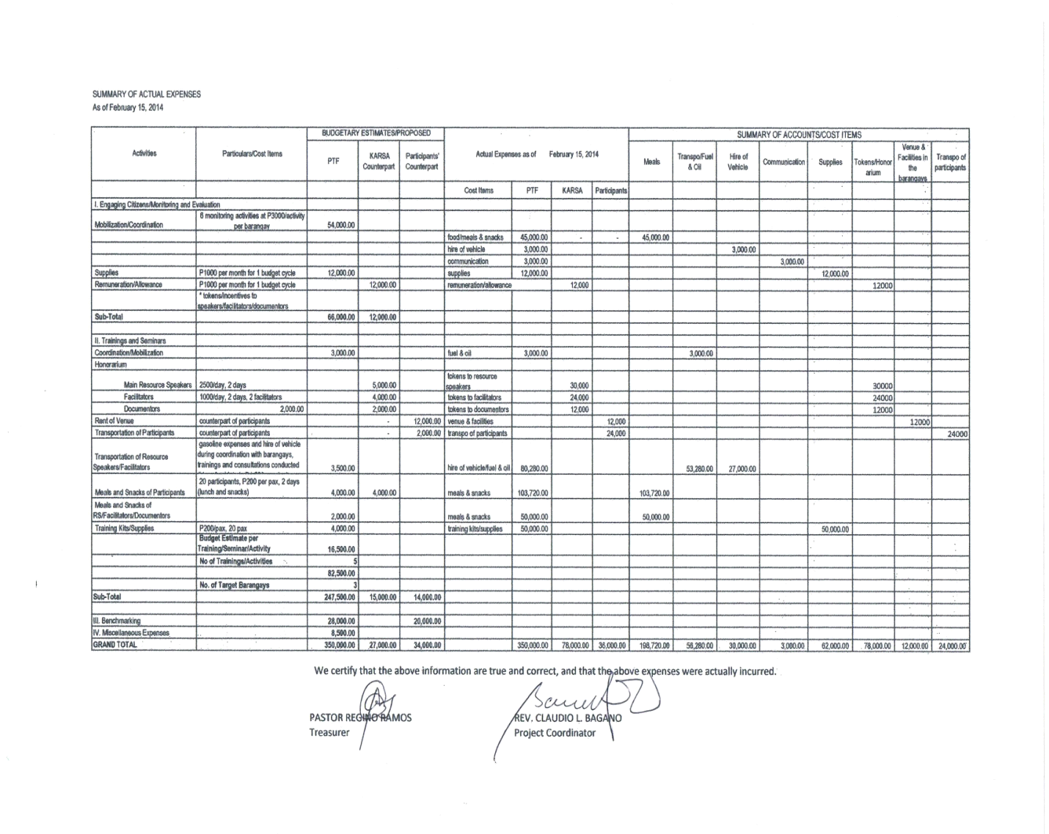

ANNEXES
These annexes are added to this report in an atempt to give more detailed explanations on the results of the activities done by KARSA relative to its program on STRENGTHENING LOCAL CAPACITIES IN GOOD GOVERNANCE where PTF and ANSA-EAP assisted as partners.
A-1. Dialogue with candidates and voters education. This activity allowed the candidates to tell to the public why they want to run for certain positions while the citizens were given chance to vintilate also what they want to be happen especially during campaign period. The purpose was to avert possible dirty tricks or politicking between the candidates during campaign period where some candidates result to destroying the image or dignity of the oponent in order to gain more sympathy votes. Since most of the candidates are related in some degree by consaguinity or affinity with each other, they agreed just to sell their platforms without necessarily "throwing dirts" to each other. Whoever will violate such agreement shall be liable to the elders(of each tribe/cultural group) who may declare that he/she should not be voted by the public or that because elders mandatewere violated by him/her, he/she is declared untrustworthy therefore not worthy of their votes. In a very cultural community like Kalinga, this dialogue leave the candidates with no other course than to mentain and be faithful to their comitment thus resulting to a peaceful and clean campaign season. Respect among Cadidates were mentained and use of money and voted buying was controlled. Candidates refrained from dirty politics and open votebuying.
A-2. Voters education directly influence some voters in a way that they were made aware of the agreement during the candidate-citizens dialogue. They became watchdogs of the elders in their respective areas to monitor the candidates on how they manage their campaign sorties. Some citizens actually became voluteer member of text brigade to inform the elders and candidates of any politician resulting to dirty politics of vote buying. Through citizens voters education they were able to choose who among the cadidates is closer to the kind of christian leadership they were looking for. Content or topics in the voters education became discussions in the families, small groupings and sectoral groupings in the local communities. Some group also(like the youth and women) were able to agree among themselve to realy implement posting area and the size of placards the candidates should be using in their respective barangays/areas. They assign posting areas in every barangay or purok then remove all placards outside the posting areas and detached all oversized placards entering their jurisdiction.
A-3,4. Trainings and seminars on social acountability. The trainings caused each barangay to have their initial baranagay plan and budget which actually was the consolidation of those priorities that came out from their purok consultations. These plans and budget were forwarded to the barangay council concerned for consideration. It was in here where the BMTs helped in its preparation and finalization in the baranagay sessions before it was forwared to the City for review after which the BMTs again helped in bringing the approved budget to the local puroks for information. Follow ups are part of BMTs tasks which they are doing faithfully at their own capacities. That forms part of what they are reporting to KARSA whenever they have to. KARSA for its part is assisting BMTs to directly monitor the execution. Part of the agreement between KARSA and barangays is for KARSA to monitor the strick and proper execution of the budget by the barangay officials, this is in fact being done through the BMTs. Thus the content of their report to KARSA is their experiences encountered in their engagement with the local officials and how the budget is being implemented according to plan. The Limitation however is, We can not expect the BMTs to be reporting in writing to KARSA as if they are the staff of KARSA because they are still "ill equiped" aside from being volunteers. The good news is they have time, they volunteer, they get involved, actively participate and keep inviting more to participate and they are happy doing their tasks/ work. With KARSA, BMTs are willing to follow-up and monitor all plans for 2014. We must sustain and ecourage them more especially by equipping them on documentations and monitoring skills and little by little we can change the situation in the near future. Guess, time is of the essence here.
With their limited trainings and orientations, the BMTs armed with their volunteerism tried their best to help in the purok consultations made by the barangay officials to explain the budget processes and officials acountabilities. It was learned that these volunteers are easier to be understood by the citizens when they talk in the purok meetings, ( maybe they hold that moral ascendancy). Thus the officials always see to it that BMTs are present during meetings. They are very much open for BMTs or citizens participation now. This BMT and official partnership started earlier in the third quarter of 2013. It was discovered that a need for wider feedback mechanism, deeper knowledge sharing and regular processing of experiences ushered the idea of having BMTs to report to KARSA later in the fourth quarter.
A-5. On transparency of baranagay budget - Budgets are being posted in more public places where citizens can easily have an access to it. This helped citizens to evaluate or assess by themselves if what they aired during the purok consultations areactually reflected in the approved plan and budget. BMTs are the front liners with the baranagay officials to explain to the local citizens what ever is not clear and how the approved budget came to be like that. Of course most of the BMTs in the barangay are not accountants or even at least with accounting units, so with the baranagay officials. This is the reason for KARSA to assist them by planning to have trainings or seminars on acounting for non-accountants, financial analysis and management, etc., so that at least BMTs can articulate better whatever is not clear on the budget to the common citizens. With the target enhancing seminars, the BMTs and even citizens can participate more meaningfully in the processes of budgeting from preparation to execution and that unnecessary budget realignment is prevented.
A-6. On citizens participaton mechanism in the barangay - (please see #7D and on the other important notes # 6&7 above) The priority projects like school buildings, health facilities, drainages, environmental, peace and order issues, etc., are better and easier be implemented for the support of the local populace is already in place because it came from them. Civic groups like the BMTs and other volunteers can take hold of these priorities untill they would land in the plan and budget during the preparation in the barangay officials' session. This purok or zone and sectoral consultations are becoming a tradition of every baranagay partner as part of the plan and budget preparations and because it is a nice startegy, It would be best if this mechanism be supported by a policy or internal guidelines or barangay ordinance to guaratee that next officials can follow it and that it will assure that officials reaching out to their constituents are institutionalized. Maybe this will be worked out by the BMTs with KARSA within this second orthird quarter of 2014.
A-7. Inter-barangay meetings- This inter-barangay activity started very recently. Barangay partners Magsaysay, Laya West and Casigayan have done this activity during the assembly of Magsaysay and during the purok consultations. It is where Laya West and Casigayan have learned the following: that presence of Sectoral representatives in the community are necessary, That peoples concerns must be heard and officials listen, That plans and budget must be based from peoples concerns, because they know best. That Sharing of other barangays experieces on how to come up with their plans and budget enhances the each others plan. That Importance of purok/zone consultations was highlighted. That posting of notices, plans and budget in more public places including churches is better and can inspire wider support from citizens. That before budget execution, approved budget be presented again to the sectors and puroks, etc.
Since this is a new activity, we still need to see how we can improve it and have it a regular activity in all our barangay partners. We still need to assist our parners to maximize their learning from this activity.

