

**Project Completion Report**

***Citizens’ Action to Enhance the Development Impact of***

***the ROSC-II Project***

***in Northwest Bangladesh***



**By RDRS Bangladesh**

**June 2015**



Table of Contents

1 Executive Summary: 4

2 Background: 5

2.1 Description of ROSC II 5

2.2 Description of the CARTA sub-project 6

3 Data collection tools and methods: 7

3.1 Community Score Card (CSC): 8

3.2 Survey: 8

4 Findings: 9

4.1 Outcome 1: An assessment [of the ROSC II project] is conducted and findings communicated to ROSC-II implementers 9

4.2 Outcome 2: The parents committee are better equipped with social accountability tools to allow them to perform their role more effectively 11

4.3 Dissemination of results and outcomes: 13

5 Project Management: 14

5.1 Implementation Challenges: 14

5.2 Sub-project activities sustainability: 15

6 Lessons learned and Recommendations: 15

6.1 Lesson learned: 15

6.2 Recommendations 15

7 Annexes 18

7.1 Logical Framework: 18

7.2 Sub- project work plan 19

7.3 Overview of Activities and Outputs 20

7.4 Beneficiaries 21

7.5 CSC report 22

7.6 List with place and dates of main project related to SA tools ( Community Score Card ) 38

7.7 Survey questionnaire 40

7.8 Case study 1 52

7.9 Case study 2 53

7.10 Case study 3 54

7.11 Case study 4 54

7.12 Case study 5 55

7.13 Report On Learning Centre (LC) Management Training 56

**Acronyms**

**AUEO Assistant Upazila (sub district) Education Officer**

**CARTA Citizen Action for Results, Transparency and Accountability**

**CBO Community Based Organization**

**CSC Community Score Card**

**CMC Centre Management Committee**

**CMG Community Monitoring Group**

**CRC Citizen Report Card**

**DPE Directorate of Primary Education**

**DPEO District Primary Education Officer**

**FGD Focus Group Discussion**

**GPS Government Primary School**

**LC Learning Centre**

**MoPME Ministry of Primary and Mass Education**

**PO Participating Organization**

**ROSC Reaching Out of School Children**

**TC Training Coordinator**

**TPM Third Party Monitoring**

**UEO Upazila (sub district) Education Officer**

**UNO Upazila Nirbahi Officer**

**UP Union Parishad**

# Executive Summary:

The project, *Reaching out of school children* (ROSC –II), developed as a second-chance education option for dropouts, as well as for children between the ages of 8 to 14, who never enrolled in primary school. The ROSC-II project is expected to contribute to enhanced economic opportunities for disadvantaged children by bringing them into the productive workforce, and thereby lifting them out of poverty. This objective is well aligned with the country’s National Education Policy (2010), Sixth Five-Year Plan (2010/11-20014/15) and the Perspective Plan 2021. The Department of Primary Education of Bangladesh Government is implementing the ROSC-II project with financial support from the World Bank.

As part of the implementing agency’s efforts to continually look for feedback from the ROSC-II community and other stake holders, a CARTA sub-project, *Citizens’ Action for Enhancement of Development Impact of ROSC-II Project through Transparency and Accountability Mechanisms in Northwest of Bangladesh,*was introduced. The sub-project covered 135 learning centers in 27 union parishads in 3 upazilas: Lalminirhat sador, Aditmarai and Badorgonj. The sub-project lasted from February 2014 to March 2015, and was implemented by RDRS Bangladesh with support from Manusher Jonno Foundation.

The objectives of the sub-project were to verify and gather information from the communities about several ROSC processes, including the selection of a Learning Center location, students and teachers; teacher training; and, a student’s access to benefits. The sub-project was also asked to strengthen capacities of the Center Management Committee and parents to supervise and assess the performance of the Learning Centers.

The sub-project used a survey, community score cards, focus groups, interviews with key informants and input-tracking to collect data and corroborate findings. The survey sampled 500 parents and students from ROSC II schools in both CARTA and non-CARTA areas of Gaibandha, Rangpur, Lalmonirhat and Nilphamari districts. A community scorecard process was used to build capacity among parents and Center Management Committee members to better understand the ROSC II objectives and guidelines, and be involved in monitoring of activities. The first community scorecard procedure was based on indicators prepared by RDRS’s capacity-building team, while the second was based on indicators prepared by the parents and Center Management Committee in the same locations. The parents and CMC were less interested in making a comparison between the two CSCs, and more concerned with creating an action plan to improve the center based on their indicators. The action plan is forward-looking and being followed up by the parents and Center Management Committee.

The survey data revealed several problems in the ROSC II implementation. Most of the center management committees (CMC) were formed by the single decision of a learning-center teacher, neglecting input from members. As a result, most of the committee members in the sample were unaware of their role and responsibilities, which meant that certain activities were not undertaken. For example, monthly meetings were not held regularly, selection criteria for students were not followed, and participatory decision-making was not used. More specifically, the following issues were found:

**Location selection:**

* 55 LCs out of 135 were located at the residence of the teacher of LC.
* In more than 70% of surveyed areas safe drinking water was not available. In case of urgent need, students collected water from an adjacent tube-well of a house owner or other family member of the teacher.
* Only 17% of LCs had ground or sports facilities for male and female students.

**Student selection:**

* More than half of surveyed parents said that their child never went to a government primary school, and that their child had instead been admitted first into an LC.
* Two-thirds of surveyed parents were unaware of the admission criteria for children to enter an LC.

**Teacher selection and training:**

* Teachers sometimes missed classes because they had external responsibilities. For example, out of 135 LCs, 49 teachers were enrolled in a nearby university as a student, which meant that they had schedule conflicts. Still, most of the surveyed parents reported that the classes were held most of the time. (More data is needed to quantify this opinion.)
* 29% of surveyed parents claimed that the LC teacher was not well-qualified, and that they were not teaching students properly.
* 35% of the surveyed parents were unaware of the teacher-selection process**.**

**CMC membership:**

* 33% of parents were not aware of a CMC in their schools.
* 57% of CMC members reported that they had no knowledge of disclosing income and expenditures for public viewing.

The overall results from using the Community Score Cards as an experiential, capacity-building exercise, were positive. In areas where the CSC process was used, CMC members were trained to manage the learning centers. Now, most of CMC committee members in these areas are aware of their roles and responsibilities. Consequently, meetings were held regularly, with decisions made in a participatory manner, and 100% of LCs in the CARTA areas displayed annual plans. A linkage was also established between the local government, community and learning center, resulting in improved environmental conditions of LCs. In several cases communities contributed money to make improvements to the school. Overall, communities that received training showed greater positive interest in the learning center, primarily because they were more knowledgeable about the ROSC II project guidelines, and their own responsibilities, to ensure that the rules were followed.

# Background:

## Description of ROSC II

The Government of Bangladesh (GOB) has undertaken many interventions, as part of its National Education Policy (2010) objective, to achieve universal primary education before 2015. The *Reaching out of School Children* (ROSC-I) Project, launched in 2004, provides a second-chance for primary education to out of school children in targeted rural upazilas. The ROSC I & II[1] projects complement the efforts of the PEDP in improving access, quality and education management at all levels. ROSC blends a formal-education curriculum with non-formal means of delivery, providing children with an opportunity to complete grade five and transition to secondary education. The ROSC project established 13,102 learning centers (LC) in selected areas to attract the targeted students.

ROSC LCs were established to meet the demand of local people. To ensure input from the local community, a nine-member center management committee (CMC) was formed to manage an LC, with at least four members selected from the parents of students. The membership requirement is shown in the next table:

|  |  |
| --- | --- |
| **Type of member** | **Quantity** |
| Father/Mother/Parents of LC Students | 4 (male-1, female-3) |
| Teacher of LC | 1 (acts as secretary) |
| Member of union perished | 2 (ward member-1,reserve women member-1) |
| Head teacher of Government primary school | 1 |
| Education potential person selected by parent | 1 |
| **Total** | **9** |

The CMC committee is responsible for overall management of an LC. The role and responsibility of a CMC are listed in the guidelines, including:

1. Completion of all procedures to establish an LC.
2. Preparation of an annual action plan and implementation of the plan.
3. Periodic report submission to an upazila education officer
4. Ensure required environment for LCs including: sufficient ventilation in the meeting space, potable drinking water, and a hygienic latrine.
5. Regular follow-up of attendance of teacher and students.
6. Ensure accountability of LCs teacher.
7. Conduct meetings as needed.
8. Preparation of previous meeting minutes /documents and take action.

## Description of the CARTA sub-project

The sub-project was funded under the C**itizen Action for Results, Transparency and Accountability (CARTA)** program, which is being managed in Bangladesh by Manusher Jonno Foundation in partnership with the Partnership for Transparency Fund (PTF). Manusher Jonno Foundation and PTF provided technical support; RDRS Bangladesh was responsible for overall project delivery. The key objective of the sub-project was to provide data to improve the implementation of ROSC II and the effectiveness of education services provided by the Learning Centers (also referred to as Ananda Schools). More specifically, the sub-project objectives were to:

* Verify the selection process for LC location and school conditions;
* Verify the process for selection of teachers, and the provision of training to these teachers;
* Verify the enrollment of students, and their access to the benefits;
* Strengthen the capacity of the Center Management Committee (CMC) and parents to supervise and assess performance of the LCs by introducing the Community Score Card (CSC) tool.

Table : Sub Project Locations:

|  |  |  |
| --- | --- | --- |
| Name of District | Name of Upazila | Name of Union |
| Lalmonirhat | Sadar | Harhati, Mogolhat, Kulaghat, Barabari, Mohindronagar, Panchogram, Golconda, Khuniagas and Rajpur |
| Aditmari | Vadai, Mohiskhoca, Polashi, Kamlapur, Durgapur, Vlabari, Sarpukur and Saptibari |
| Rangpur | Badragonj | Radhanagar, Gopinathpur, Ramnathpur, Damodarpur, Modhupur, Gopalpur, Futukpur, Lohanipara, Kalupara, and Bishnopur, |

S**ub-project budget and time frame:**

Total Sub-project Cost: BDT 67,22,430: USD 87,304

Organization Contribution: BDT 5,62,429: USD 7,304

Time frame: February 2014 to March 2015

# Data collection tools and methods:

The CARTA sub-project had two main activities: collecting data about the ROSC II implementation and second, providing capacity-building to increase the knowledge and skills of CMCs. This capacity building was done through an experiential learning process where the CMC members conducted two community score cards, and thus participatory processes, with stakeholders.

An overview of all the data collection and training methods used by the sub-project included:

* **Community Score Card (CSC):** Two CSCs were used to collect information from parents, community members, and students of Ananda Schools (the Learning Centers), which were established in 2013. The purpose was to find out about their experiences, perception and satisfaction levels with Ananda Schools. The CMC experience was used as an experiential training tool, and as mentioned earlier, not undertaken as a conventional CSC process. Two sets of indicators were used and therefore the two rounds cannot be compared. The community scorecard was used primarily to meet objective two, i.e., building the capacity of the PC and others, to use social accountability tools to improve the performance of the LCs.
* **Survey:**  A survey was used to collect data about various processes in the ROSC II project. This snapshot was not intended to make comparisons with the CMC data, and was not used to analyze trends. The survey was used to meet objective one, i.e., to provide data on the selection processes and other factors the affect the performance of the LCs.
* **Input-tracking**: RDRS staff checked field documents to verify the data provided in reports. The staff examined primary documents on the operation of the LC, including information on drop-outs, student enrollment status, age of students, attendance rates, and the location of teacher from the LC. The RDRS staff also observed the facilities.
* **Focused Group Discussion (FGD**): 10 FGDs each consisting of 10 CMC members in both Rangpur and Lalmonirhat districts were completed to corroborate the findings of the survey
* **Key Informant (KII) Interviews:** Several KI interviews were completed with Upazila Nirbahi Officers (UNO), the Upazila Education Officer (EO), the headmaster of the mother primary school, UP Chairmen and members, to corroborate information gathered from other sources.

## Community Score Card (CSC):

The first Community Score Card (CSC) process had two objectives:

* To verify several selection processes under ROSC II (LC selection, teacher, and student).
* To improve the capacity of the parents committee and other stakeholders to monitor the quality of education and to hold LCs accountable.

After the first CSC, a third objective was added:

* To use new, mutually agreed indicators to prepare an action plan for the LC

The sub-project completed two different community score card in 135 LCs in the sub-project upazilas. The first CSC gathered data from April to June 2014, while the second CSC was completed from October to December 2014. There were a total of 14,494 persons who participated, including students, CMC members, parents, others.

The CSC report is included as an annex 7.5. The report describes the methods used, the areas covered, outcomes and challenges.

## Survey:

The survey was used to meet objective one, i.e., to provide data on the selection processes and other factors the affect the performance of the LCs.

A questionnaire was used to conduct a survey of parents and students. The questionnaire was developed in consultation with stakeholders (including the WB, RDRS and the Primary Education Department). After drafting, several field tests were conducted.

An external consultant was hired to create the survey, and manage the data-collection process[2]. The consultants recruited 12 (female: 8; male: 4) enumerators. To ensure quality, the staff was trained and a probability sampling guideline was given to data enumerators. A one-day orientation was provided to enumerators on collection methods, both qualitative and quantitative, from the targeted villages. A supervisor ensured the data collection consistency. Data was collected from field during September and October 2014—(between the two community score card data collection months). For FGDs and KII interviews a checklist was developed to guide the interviews.

The survey targeted a total of 518 parents[3] of registered students in Ananda schools in both CARTA and non-CARTA areas (there were 100 parents from non-CARTA areas). The purpose of including a small number of non-CARTA areas was to see if the first community scorecard process had any effects in the CARTA areas. Geographically, 50 LCs (35 CARTA LCs and 15 LCs from non-CARTA areas) were selected. Ten parents, with enrolled students, from each Ananda School were randomly selected for interview. The following table summarizes the respondent distribution.

|  |  |  |  |  |
| --- | --- | --- | --- | --- |
| District | Name of Upazilla | Respondent from  CARTA area | Respondent from Non-CARTA | Total respondents |
| Ghaibandha | Sundargong |  | 10 | 10 |
| Kurigram | Phulbari |  | 20 | 20 |
| Lalmonirhat | Lamonirhat Sadar | 93 | 33 | 126 |
|  | Aditmari | 105 | 39 | 144 |
| Nilphamari | Jaldhaka |  | 21 | 21 |
| Rangpur | Badargong | 152 | 45 | 197 |
|  | | 350 | 168 | 518 |

(The questionnaire is included as annex 7.6)

# Findings:

## Outcome 1: An assessment [of the ROSC II project] is conducted and findings communicated to ROSC-II implementers

In particular, the specific objective of this outcome is to verify several selection processes under ROSC-II (LC locations, teacher and children). The survey data showed that for the:

**Selection process for LC location and condition:**

* Around three-fourths of surveyed parents in CARTA areas and 66% in non-CARTA locations mentioned that they were consulted about the establishment of the LC in their community.
* However, even after being consulted, one half of surveyed parents (52% and 50%) in both CARTA and non-CARTA areas admitted to being aware of the LC selection process.
* And, of those who were aware of the process, half in CARTA areas thought the selection was properly done; this rate is lower in non-CARTA areas. It is important to note that for both areas around one third of surveyed parents are unaware whether the selection was properly done or not.
* The survey found that in 10 communities (out of the 35 sampled LCs where CARTA program was implemented) either a school teacher or president of the CMC was the owner of the classroom.
* In more than 70% of surveyed areas safe drinking water was not available. In case of urgent need, students collect water from an adjacent tube-well owned by either house owner or other family members. The poor access to water and sanitation facilities at LCs was disconcerting. Also, there were few playgrounds or sports facilities for students at the LCs. The poor facilities could be explained by the fact that the LC classroom was often located in the house of a teacher or headmaster, who may have preferred this option because they received a small rent for the facility.

**Teachers Selection and Teaching Quality:**

* More than half (58% in CARTA areas and 55% in non-CARTA areas) of surveyed parents were not informed about the final result of the teachers’ recruitment examinations.
* Almost one-fourth of all parents claimed that the teacher didn’t live close to primary school. The average distance of a teacher’s residence from their respective LC is around 1.2 kilometers.
* Most of the respondents had heard about training for the LC teachers; however, monthly teachers’ group meetings were not being held in most of schools.
* 29% of surveyed parents of the students in CARTA areas claimed that LC teachers were not well qualified, or teaching students properly.
* Teachers didn’t communicate with the Head Teacher of the mother primary school regularly about the quality of education.
* Around three-fourth parents in both CARTA and non-CARTA school reported using education materials.
* Around one-tenth of parents of both CARTA and non-CARTA schools claimed that most of the time their children experienced the use of corporal punishment.
* 49 teachers (out of 135 LC) are students themselves at university. They are often busy with university activities, and did not work at the schedule times in the LC. Still, most of the surveyed parents reported that the classes were held most of the time.

**Student selection process and education support program:**

* One-third of surveyed parents in CARTA schools and one-fourth in non-CARTA schools are aware of the criteria for admission of children into the LC.
* More than half of surveyed parents (56% in CARTA and 57% in non-CARTA LCs) admitted that their child never went to the mother primary school, that their child had been admitted first into an LC.
* Around 84% of parents in CARTA areas received their stipend regularly compared to non-CARTA areas (64%).
* Around 15% in CARTA schools and 19% in non-CARTA schools reported that fees were deducted from the stipend without any receipt.
* Proper monitoring of LCs by CMC, PO and TC was reportedly low. The CMC’s monitoring role appears to be greater in CARTA areas, where more training was given.
* According to the FGDs, many students attend LC classes intermittently. (More work would need to be done to confirm the percentage.)
* In the interface meeting it was reported by several community attendees that their involvement in the student selection process was very limited; the student list was more often prepared by the partner organization[4].
* Generally, most of the parents reported that the benefits provided to the enrolled students by the LC are better than the government primary school. Provision of stipends for LC students is thought to be one reason why students attend; yet, only 12% parents of children of the LC in CARTA areas claimed that they enrolled their child in an LC to receive the monthly stipend. (More data is needed to examine this issue. This percentage is lower than that reported anecdotally in the FGD meetings. It may be that self-reporting one’s intention is not possible with this question due to the respondent’s perceived consequence if they affirmatively answer.)
* Several parents reported undue influence by some influential people to make a child eligible to gain admission. This was one reason given for the parents’ dissatisfaction with the student-selection process.

**Transparency and Accountability in CMC Functioning:**

* 17% of parents in CARTA areas and 33% of parents in non-CARTA areas are not aware of a CMC in their school.
* Only 43% of CMC members in CARTA areas and one-fourth in non-CARTA areas reported disclosing income and expenditures to the public.
* There was a large difference in perception between CMC members and parents concerning the degree of CMC oversight of the LC and teachers. CMC members felt they provided some oversight, while parents generally felt that the CMC was not providing sufficient levels[5]. For example, half of the surveyed parents in CARTA areas reported that the CMC failed to monitor attendance of students and teachers.
* Three-fourths of parents in CARTA areas claimed that local leaders visited the school to inspect, and around half (54%) parents in non-CARTA school claimed having had a visit.
* Half of the surveyed parents (46% in CARTA and 51% in non-CARTA areas) believe that there is no system to file complaints. Of those who filed complaints, 42% of parents in CARTA areas and 59% in non-CARTA areas reported that these complaints were not addressed.
* Based on the FGDs and KIIs the following comments were also noted: teachers don’t communicate regularly with the head teacher at the mother primary school; and, monitoring by the CMC, PO and TC has generally not been effective.

## Outcome 2: The parents committee are better equipped with social accountability tools to allow them to perform their role more effectively

In particular, the specific objective was to improve capacity of the parents committees to monitor the quality of education and to hold LCs accountable.

RDRS successfully used two community score card (CSC) cycles with the parents’ committee (PC) and other stakeholders to build their capacity to gather information about the performance of the LC. During each cycle, the community was engaged in participatory learning experience where they practiced using the tool. As a result of the knowledge and skill building from the two lengthy CSC processes, the following changes were noted in the sampled areas by the end of the sub-project:

* Most of communities, parents and other stakeholder were aware of the objective of ROSC-II and selection criteria for LCs. Through the learning process of using the CSC, the PCs had a better understanding of the ROSC project and could demand, with confidence, more oversight by the CMC.
* Most CMC members were aware of their roles and responsibilities; one visible result was that the CMC meetings were held regularly. (RDRS augmented the learning through the CSC cycle by organizing over 600 monthly CMC meetings to give members hands-on experience running such events, while also providing management training to handle difficult issues.)
* Links among union parishad, teachers, guardians and other stakeholders increased, with stakeholders performing their duties regularly. (RDRS augmented the learning through the CSC cycle by organizing 27 union-parishad-standing-committee meetings to increase LC linkage development.)
* CMC visits to LCs increased after the CARTA intervention, and community action plans were made to further improve LCs. (With the cooperation of the UP, the community, and CMC members, there were improvements to the LC environment—17 LCs installed a tube-well, 32 constructed a sanitary latrine, and 57 improved the ventilation in the meeting space.) Also, several communities helped fund improvements such as the construction of an interior ceiling below the roof to insulate the classrooms from the heat, while others added ceiling fans. This was done with support from the community.
* To expand the creativity of students, several LCs organized annual sports events and a picnic with the support from union parishad and the community. These events were organized for the first time in many locations, creating an example of community engagement.

As part of the modified CSC process, an action plan was jointly created to resolve the issues discovered from collecting data. This community action plan (CAP) was prepared after a CSC interface meeting with the community and other stakeholders. Because these plans were so important in bringing about the changes, an actual plan created by one community, is shown in the next table:

|  |  |  |  |  |  |
| --- | --- | --- | --- | --- | --- |
| SL No | Activities Plan | Time Line | Suggestion | Responsible person | Follow up by |
| 1 | To organize regular meeting of CMC | Continue | Teacher of LC inform to CMC before 7 days at held meting and next meeting time will fix by the participatory way in this meeting. | 1. President of CMC 2. Teacher | Monitoring group |
| 2 | To ensure available safe water and sanitation | July-August’14 | To available of existing resource and mobilize with local government and participation of community. | 1. CMC 2. Guardian 3. House owner | Monitoring group |
| 3 | To ensure sufficient light and air circulation | July ‘ 14 | To cut door and set up lighting tin sheet and if will possible than set up fan. | 1. CMC 2. Guardian 3. House owner 4. Local government | Monitoring group |
| 4 | To see presence and disappear of teacher | Continue | Follow the existing time schedule of ROSC II project. | 1. CMC 2. Guardian | Monitoring group |
| 5 | To increase communication between guardian and LC's | Continue | Conduct parents gathering, home visit and guardian look after to LC willingly. | 1. Teacher 2. CMC 3. Guardian | Monitoring group |
| 6 | LC's Visiting and Recommendation by CMC and Education Standing Committee (ESC) | Continue | To inform ESC about ROSC II and prepared them how to work in LC for further improvement | 1. Teacher 2. CMC 3. community | Monitoring group |
| 7 | To prepare annual and quarterly plan at LC's and institutionalization | July 14 | Starting year annual plan will be prepared and every after three month quarterly progress report prepared | 1. Teacher 2. CMC | Monitoring group |
| 8 | To ensure cleanness of the students | Continue | Improving all over environment of LC and aware to guardian about cleanness of student | 1. Teacher 2. CMC 3. Guardian | Monitoring group |
| 9 | To increase home visit of CMC | Continue | CMC visit these students home who are most of the time absence at LC | 1. Teacher 2. CMC | Monitoring group |
| 10 | To Increase Use of education materials | Continue | To develop education materials in LC by the local community, guardian and ROSC II support. | 1. Teacher 2. CMC 3. Guardian | Monitoring group |

## Dissemination of results and outcomes:

Achievements, outputs, and outcomes have been shared with communities to encourage them to continue their work beyond the sub-project period. The primary methods were:

* An exit meeting was organized with the UP stakeholders and community members to share the findings.
* Lessons learned and recommendations from the communities were also shared with Manusher Jonno Foundation, PTF, and the World Bank.
* Exposure visits to communities with exemplary outcomes were organized for weak CMC committee members to provide relevant experiences and possible solutions to their problems.
* A public Community Action Plan (CAP) cycle at 135 LCs was created that showed the issue and the steps needed to resolve it.

There were several improvements in the operation of the ROSC-II project that can possibly be attributed to sub-project information disseminating activities. For examples, consider the following:

**Accountability:** Before started the sub-project most of the CMC committee members were unaware of their role and responsibilities, which is the reason they most often claimed, why they did not engage in the ROSC project. After experiencing the CSC process, they visibly became more active, demanding more accountability from the service provider, with the result that service providers became more openly accountable for their decisions in meetings. While it is difficult to measure the change in accountability, it was clear that increased awareness had changed relationships. For example, the CMC members generally reported that LC teachers were more responsive to committee members and the community.

**Participation:** It is evident that the degree of citizens’ engagement in ROSC-II increased through CARTA sub-project. While it is difficult to measure, communication between the various actors has improved, and the relationship between citizens and the service providers is more hopeful. The CMC committee and local community are now playing the roles envisioned in ROSC II. It is still not clear, however, that the participation by more marginalized people has happened, but the involvement of the community in the school is tangible (judging by the investment in capital improvements for example).

**Transparency:** The shift from a mindset of restricting information to disseminating information is one of the major achievements of this sub-project. Now, detailed information about ROSC-II is shared with the LC community. More information is shared during meetings, orientation and CSC activities .It is now possible to find out under-age, over-age, drop-out rates and even duplicate enrollments (enrolled at the same time of LCs and other school).

**Efficiency:** Most of the CMCs, as a result of CARTA activities, are carrying-out the activities as per their role and responsibilities. They organized their meetings regularly, and also made decisions using participatory ways. For example, teachers are required to record their attendance, including arrival and departure time, and to request leave from the CMC. Such oversight will hopefully result in better use of resources.

These statements, of course, cannot all be attributable solely to the sub-project activities—this study did not use an experimental design, and some results could probably be the affect from other training and resources. It is not easy to always identify why a community member feels suddenly empowered to improve the quality in an LC, or why a local political leader finds it necessary to have more participation in a process. What is clear is that knowledgeable citizen engagement can be a catalyst that can bring about change. The people who experienced the sub-project activities repeatedly said that without this intervention change would have happened more slowly, or not at all. Citizens demand the continuation of citizen engagement, since they see it as a way to be more informed and have more control over the outcome. They also believe that citizen involvement can lessen potential corruption in public service delivery. Citizens appear to be willing to spend their time providing oversight; they also appear to be growing in confidence about their own power to control the outcomes in their community.

# Project Management:

A central office was set up in the RDRS Bangladesh premises in Lalmonirhat, with 3 field offices in Lalmonirhat sador, Aditmari and Badorgonj. Three field-managers were responsible for upazila level field operations; each coordinated with the upazila-level government’s officials, implementing agency, local government and other stakeholders. One project manager was recruited for overall project management with one technical officer engage in monitoring and documentation.

The primary activities of sub-project included:

* Foundation Training / Orientation for project staff
* Inception meeting with local authorities and multi-level stakeholders
* Community Score Card ( Input tracking, FGD, Interface meetings)
* Bi-monthly CMG/ CMC meeting
* Meeting with UP education standing committee and Local Government
* Orientation / Training for community and officials on CSC
* Survey
* Secondary document review
* Publication / Documentation

## Implementation Challenges:

RDRS experienced several challenges during the implementation of sub-project:

* There was occasional pressure from powerful individuals to influence decision-making during interface meetings, data collection, and KII.
* The communication between ROSC project implementators and citizens was hampered by a lack of understanding of citizens’ engagement as a tool to bring about improvement in outcomes, and not as an effort to create evidence that would be used against them. Many LC teachers didn’t like a participatory, democratic decision-making process or community engagement in general; they were used to having sole decision-making responsibility.
* Several community recommendations required extra funding that was beyond the scope of this project. It was necessary to control expectations.
* Citizen engagement is a lengthy process that requires many interactions between all the actors, yet it is very challenging to insist that working people be present for numerous meetings and activities.
* Finally, the sub-project lasted 13 months with even less time in the field, which is a short time to know results and institute changes that are sustainable.

## Sub-project activities sustainability:

It is hoped that the sub-project outcomes will be long term, but the short sub-project term made institutionalizing many activities difficult. Some positive signs were found—CMC members enjoy knowing their roles and responsibilities, and the local communities were showing more interest in the learning center. Also, LC teachers and the CMCs were more responsive to the community, and linkages among union parishad officials, teachers, parents and other stakeholders increased. Perhaps all of these changes will have tangible benefits—enough to keep the practices going. It is still too early to know, yet tendencies to lapse back to inactivity seem unlikely now that the community has a sense of empowerment.

# Lessons learned and Recommendations:

## Lesson learned:

RDRS learned several lessons during the implementation of this sub-project:

* A temporary social interface, such as a CSO, can reduce the distance between a service-provider and a service-receiver by creating a bridge, which may initially assist better understanding.
* A participatory training approach should also empower attendees. Training without empowerment can only lead to less and less knowledge transfer to subsequent cadres of learners. At some point learners have to create their own knowledge, based on their experience, for the effects to be long term.
* More time is probably needed to institutionalize citizen engagement activities.
* Citizen engagement is a useful approach to verify the results of public projects and assess the implementation process.

## Recommendations

**LC Selection and Compliance with the Criteria**

* An independent CSO could provide an environmental and social assessment of potential LC sites that would inform the selection process. This independent CSO, rather than a PO, could participate in the public hearing to objectively explain the various issues involved in making the selection. The community could then finalize the location of Ananda School, based on independent information. This more objective process could build a sense of fairness which may encourage more input from marginalized members of communities.
* It should not be possible to approve any LC that does not have water and sanitation facilities.

*(*The survey data showed that 56% LCs has no facilities for safe water and 96% had no sanitary latrine. According to the *Project Implementation Guideline,* section 2.2.7*, “In [the] selection of LCs some facilities should…consider…access to safe water, arrangement of sanitation facility, [and a] quality classroom for 35 students.”)* Perhaps the wording can be changed to make the section in the guideline forceful.

* Ownership of the LC classroom should be a person who is not related to a CMC member or teacher of LC to avoid a conflict of interest.

**Teacher selection and teaching quality**

* A panel of teachers should be selected centrally to evaluate proposed teachers for an LC. The final selection of the teacher should be done on by an independent and credible GO or CSO who will verify the selection process.
* The practice of using a substitute or sub-contracted teacher instead of the full-time, qualified teacher should be discouraged, and eliminated to the extent possible. Substitute teachers are often used to replace the hired teacher when that teacher has scheduling conflicts. For example, several KIIs opined that the poor quality of teachers, is due partly to the selection of a university student as a teacher (49 teachers in the 135 sampled CARTA areas are regular university students) who are already too busy with their studies. In other cases some hired teachers have sub-contracted their position for more extended times to another teacher. It is not clear how pervasive these problems of substitution and sub-contracting are in the ROSC LCs, but the perception that the percentages are high should be addressed.
* Adequate training should be provided to each teacher in English-language, Mathematics, and student behavioral issues. Obviously these are more than short term training requirements, and may be beyond the expectations of the ROSC II project.

**Student selection process and education support program**

* A mass awareness campaign (perhaps by an independent organization with experience in disseminating information using radio) should be carried out to inform a community about eligibility criteria for students.
* After this campaign, criteria should be more strictly enforced. For example, underage or overage student should not be allowed to enroll. The headmaster should have authority to cancel such admissions. *(It has been a major concern that almost half of students in 135 LCs chose admission into the LC rather than the primary school.)*
* Students should be expected to return to the primary school. The expectation should be made clear that attendance in the LC is temporary, and that the goal is to eventually place students back into the government primary school.
* The disparity in incentives may be a partial cause of the problems of attendance. Incentives in both Ananda schools and the government primary schools might be equalized so that students in the government primary school don’t leave the primary school just to take advantage of the superior benefits offered by the ROSC LC. *(For example, more than one-third of surveyed parents admitted that they enrolled their child in the Ananda School at a lower class level then the last class attended at the primary school so that their child would receive benefits for a longer period.)*
* Automation of information for all enrolled students in both the LC and primary school in the same area should be done soon to provide sufficient data to manage the enrollment at these schools.

**Transparency and Accountability in decision making**

* Ensure 100 percent pro-active disclosures of all activities of a CMC, PO and TC.
* Since the CMC has the critical oversight role of the LC, the members must have the capacity to fulfill their roles and responsibilities. The CMC already has certain guidelines for the selection of members, but it does not give any guidance to the selection of members with the needed skills. While a member’s education level is one possible criteria to consider, this criteria can limit participation to a few individuals in a community, and most likely those already with power. If criteria could instead be based on skills or knowledge then the participation level of members with low levels of education might be increased. Also, even if members are well-educated, all members need a thorough orientation on their position as a CMC member. *(Most of the CMC were formed by the single decision of LC teachers and most of them are not skillful; thus, they did not ensure teacher accountability.)*
* There needs to be better oversight of a CMC. If a CMC is not performing perhaps the membership should be dissolved and a new election held.
* Set a public meeting schedule with open attendance, so that any parent or other concerned stakeholder can attend, and include the date minutes will be available.
* Strict, public accountability has to be instituted with zero tolerance for significant irregularities by any teacher, member of CMC, TC and PO. Of course, “significant” will have to be defined by each community.

**Standard of Education and Proper Monitoring**

* An enforceable system that rewards good performance and penalizes bad performance has to become the expected culture to drive still better performance. Currently, it is not clear who insists on such high standards. If the TC is responsible, then this person needs more assistance, given the expectations for this position. One idea to provide more assistance by engaging university graduates, who can provide voluntary services as teacher-assistants, mentors, or helpers. Perhaps an incentive system can be devised to make this possible.
* Audio-visual materials and techniques can be provided to each government primary school (mother schools only) so that students would not enrol in the LC just because it has better equipment. (It is not clear that this is a primary reason for attending the LC over the primary school, but “better conditions” at the LC were noted during the FGDs and KIIs.)

**Access to scholarship and other benefits**

* Financial benefits for each student should be credited to the bank account of a student or his/her legal guardian, and not to any intermediaries.
* A national database might be used to assist in the selection of LC students (perhaps the NID could be used).

**Complaints Redress Mechanism**

* A user-friendly complaint mechanism should be implemented to improve accountability. Ideas for such a system include an easy-to-use application for a cell phone, a toll-free hotline that allows anonymous submissions, and a UP information centre which could provide support to lodge any complaint. At the very least, regular public meetings can be arranged to report complaints openly, and then redress promptly.
* At least one regulation should be reviewed: in the ROSC-II guidelines there is no provision that explains how a *guardian* can lodge a complaint, either to a CM or a partner organisation.

# Annexes

## Logical Framework:

|  |  |  |  |  |  |
| --- | --- | --- | --- | --- | --- |
| Indicator | OVI( Objectively Verifiable Indicator) | MOV( Means of verification ) | | Assumption | |
| **General Objective:** Contribute to ensuring transparency and accountability in the implementation of ROSC-II in targeted area. | | | | | |
| **Specific objective 1** : To verify selection process under ROSC-II  ( LC locations, teacher and Children )  **Specific objective 2** : Improve capacity of the parents Committee to monitor quality of education and to hold LC,s accountability | * In the selected 135 LC,s To follow the guide line of LC Process selection, establishment , such as safe drinking water and sanitation , The circulation of fresh air and light Continuously meeting held with CMC / CMG * Improve linkage between the Community and UP education standing committee member | | * 100 % LC prepared annual development plan   (Monthly & quarterly progress report )   * Ensure 23 % LCs safe water and sanitation system * 42% LCs ensure fresh light and air | | * Favorable support from implement agency & Community * Favorable political stability & Community harmony |
| **Outcomes 1** : Assessment is conducted and findings communicated to ROSC-II implementers | * 6938 number of community people participate regular bi- monthly meeting of CMC / CMG   330 number of UP education standing committee member attend in the meeting   * 118 number of multilevel stakeholder attend in the project inception meeting. * 133 LC management committee member received training | | * Bi-monthly CMC/CMG meeting attendance and regulation * UP education standing committee meeting attendance * LC Management training attendance * Management committee training participants | | * Favorable support from implement agency & Community |
| **Outcome 2 :** The parents committee are better equipped with social accountability tools to allow them to perform their role more effectively | * 135 LC,s completed (1st & 2nd round Community score card ) * 135 number of Follow-up FGD conduct | | * Survey report * 1st & 2nd round Community score card report * Publication/ Documentation | | * Favorable support from implement agency & Community |

## Sub- project work plan

|  |  |  |  |  |
| --- | --- | --- | --- | --- |
| Major Task | 12 Months | | | |
| Quarter  1 | Quarter  2 | Quarter  3 | Quarter  4 |
| Staff recruitment / Office setup |  |  |  |  |
| Publication/ Documentation |  |  |  |  |
| Foundation training / Orientation for project staff |  |  |  |  |
| Inception / Sharing meeting with local Authorities & Multilevel stakeholder |  |  |  |  |
| Survey |  |  |  |  |
| Orientation / Training for community and duty bearers on CSC |  |  |  |  |
| Secondary documents review |  |  |  |  |
| Community score card – round ( Interface , FGD, Input tracking interface ) |  |  |  |  |
| Training for CMC/ CMG on LC Management |  |  |  |  |
| Monthly Staff meeting |  |  |  |  |
| Meeting with UP Education Standing Committee |  |  |  |  |
| Bi- monthly CMC/ CMG meeting |  |  |  |  |

## Overview of Activities and Outputs

|  |  |  |  |  |  |  |  |
| --- | --- | --- | --- | --- | --- | --- | --- |
| Project Activities | Target | Achievement | Results | Participants | | | Remarks |
| Male | Female | Total |
| Foundation training / Orientation for project staff | 1 | 1 | 100% | 11 | 4 | 15 |  |
| Staff monthly meeting | 12 | 12 | 100% | 10 | 5 | 15 |  |
| Inception meeting with local authorities and multi- level stakeholder | 3 | 3 | 100% | 93 | 25 | 118 |  |
| Bi-monthly CMC/ CMG meeting | 600 | 600 | 100% | 2545 | 4393 | 6938 |  |
| meeting with UP education standing/ local government | 27 | 27 | 100% | 243 | 87 | 330 |  |
| Orientation on CSC | 135 | 135 | 100% | 1197 | 4546 | 5743 |  |
| CSC Interface ( 1st round) | 135 | 135 | 100% | 1070 | 4562 | 5632 |  |
| CSC Interface ( 2nd round) | 135 | 135 | 100% | 1212 | 4509 | 5721 |  |
| LC Management Training | 135 | 133 | 99% | 89 | 44 | 133 |  |
| FGD ( Follow-up) | 135 | 135 | 100% | 691 | 1396 | 2087 |  |
| Survey | 1 | 1 | 100% |  |  |  |  |

## Beneficiaries

|  |  |  |  |
| --- | --- | --- | --- |
| **Beneficiaries** | **Female** | **Male** | **Total** |
| LC Students | 1981 | 2522 | 4503 |
| Parents |  |  | 9006 |
| CMC Member | 710 | 505 | 1215 |
| UP Standing Committee member | 87 | 243 | 330 |
| Community(Direct and indirect) |  |  | 20000 |
| Total |  |  | 35054 |

## CSC report

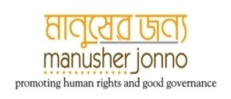

Citizens’ Action for Enhancement of Development Impact of ROSC-II Project through Transparency and Accountability Mechanism in Northwest of Bangladesh / CARTA Project

**Compiled Report on Community Score Card (CSC)**

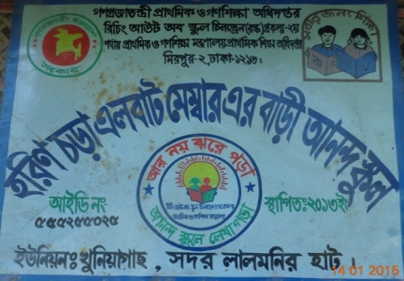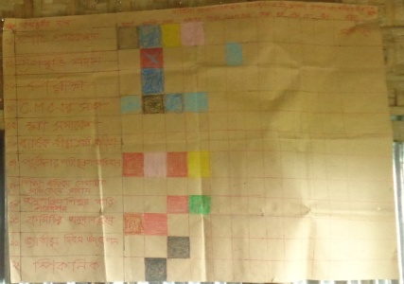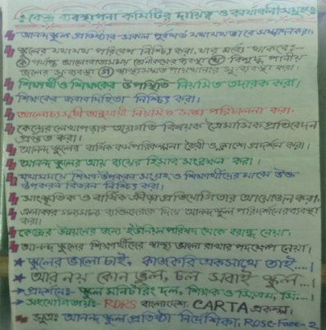

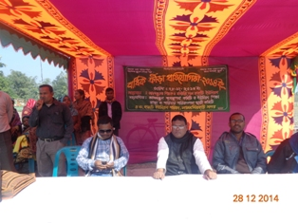

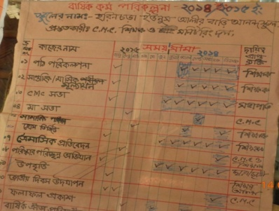

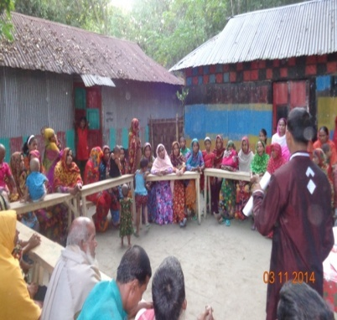

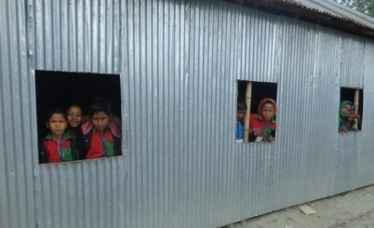

**Implemented by:**

House No # 43, Road N # 10, Sector # 6, Uttara, Dhaka-1230, Bangladesh

GPO Box: 618, Dhaka 1000, Bangladesh

Tel: Off: + (88 02) 895 4348, Fax: + (88 02) 895 4391

Email: [rdrs@bangla.net](mailto:rdrs@bangla.net), Website: www.rdrsbnagla.net

***Acknowledgment***

We would like to express our special gratitude to WB, PTF, JSDF and MJF for their support to promote enhanced citizen actions and participation in order to ensure transparency and accountability in learning center at the grass roots level of Bangladesh.

However, it would not have been possible without the kind support and help of central and local level GOB authorities, implementing CSOs, UP representatives, CMC members, teachers and guardian as well. We would like to extend our sincere thanks to all of them.

Furthermore we would also like to acknowledge with much appreciation the crucial role of the RDRS Bangladesh staff team engaged in CARTA Project implementation.

***List of Abbreviations***

|  |  |
| --- | --- |
| CARTA | Citizen Action for Results, Transparency and Accountability |
| MoPME | Ministry of Primary and Mass Education |
| DPE | Directorate of Primary Education |
| ROSC | Reaching Out of School Children |
| CMC | Centre Management Committee |
| LC | Learning Centre |
| TC | Training Coordinator |
| CMG | Community Monitoring Group |
| PO | Participating Organization |
| CSC | Community Score Card |
| CRC | Citizen Report Card |
| TPM | Third Party Monitoring |
| FGD | Focus Group Discussion |
| CBO | Community Based Organization |
| UEO | Upazila (sub district) Education Officer |
| DPEO | District Primary Education Officer |
| AUEO | Assistant Upazila (sub district) Education Officer |
| UP | Union Parishad |
| UNO | Upazilla Nirbahi Officer |
| GPS | Government Primary School |
| PTF | Partnership for Transparency Fund |
| MJF | Manusher Janno Foundation |

***Table of Contents***

|  |  |  |
| --- | --- | --- |
| ***Serial*** | ***Contents*** | ***Page no*** |
| 1 | Introduction | 39 |
| 2 | Brief Information of ROSC II | 40 |
| 3 | CSC Objective | 40 |
| 4 | CSC methodology | 41 |
| 5 | Orientation Meeting | 42 |
| 6 | Input Tracking | 43 |
| 7 | Performance Score (FGD) | 44 |
| 8 | Interface meeting | 45 |
| 9 | Average Score | 47 |
| 10 | Institutionalization & Follow up | 48 |
| 11 | Community action plan | 49 |
| 12 | Achievements | 50 |
| 13 | Major Challenges | 51 |
| 14 | Main conclusion and lesson learn | 51 |

**Introduction:**

RDRS Bangladesh with the technical assistances from Manusher Jonno Foundation (MJF) and Financial support by PTF and JSDF has been implementing the third party monitoring project (TPM) titled **“**Citizens’ Action for Enhancement of Development Impact of ROSC-II Project through Transparency and Accountability Mechanism in Northwest of Bangladesh / CARTA Project**”** to monitor services quality through community engagement of MOPME implemented ROSC-II Project within the framework of the project.

The TPM will provide community feedback to DPE for improving the responsiveness of the service providers with specific focuses o the following objectives:

Community scorecard (CSC) is an effective tool for strengthening citizen voice and promoting constructive dialogue between service users and service providers. It builds capacity of the beneficiary as well as community to hold service providers accountable To fulfill the project objectives, RDRS Bangladesh has been conducted 2 round Community Score Card (CSC) during the year of 2014 in the ROSC II project areas like Aditmari, Sadar upazila of Lalmonirhat and Badargong upazilla of Rangpur district under the CARTA Project. Key steps in implementing a CSC include:

1. Learning Center Selection process (identified LC for Community Score Card Implementation) When selected Learning Center than followed these issues like LC distance, disadvantage.
2. Conducted orientation meeting at the LC level with community people, guardian, member of local government and social elite person. Some indicator have selected by the participant to identify present situation of LC.
3. Conducted input tracking period at the LC and listed many materials of Learning Center like black board, chair table, learning materials, register etc.
4. Conducted sharing meeting at LC with service provider and service receiver.
5. Conducted Focus Group Discussion at LC with one is service provider and another one is service receiver and two group provided score selecting indicators according to their own observation (when we conducted FGD than we divided between two parts like service receiver and service provider).
6. Conducted interface meeting with stakeholders at LC and shared score of two groups with all participants in that is meeting at LC. When we prepared CSC card in that time we discussed with them about CSC score and common understanding of CSC score that according to participant opinion.
7. When interface meeting completed in that time both participators made an improvement action plan for LC within timeframe and this action plan has institutionalized.
8. Every LC have made monitoring group to work with action plan for improve condition of LC.

**Brief information about ROSC II Learning Center (Anondo School) :**

Ministry of Primary and Mass Education of Bangladesh implemented Anondo school funded World Bank under ROSC-II project. Never gone to school, droop out and disadvantage communities children and their age limit are from 8 to 14 only these criteria’s children will be enrolled in Anondo School. Since 2005 to 2009 this ministry has been implemented Anondo School in 90 upazillas and since 2012 ten thousand Anondo School have been implemented at 100 upazila in different district. Enrolment children will be study in Anondo School class from 1 to 5. According to LC implementing guideline Anondo School situated this catchment areas this catchment areas Govt. primary school will monitor this Anondo School. Children of Anondo School took steepen, dress, reading books and materials from ROSC-II project. Every upazila of implementing ROSC-II project areas have Thana Coordinator (TC) to look after Learning Center.

Every Learning Center has a Center Management Committee. This Committee plays their role and responsibility in Learning Center according to learning center implementing guideline book. Center Management Committee conducted meeting every month to improve environment of LC. CMC identify problem of LC and solved this issues by the participatory way. The Center Management Committee very effective for Learning Center.

**Center Management Committee Structure is follow:**

Total member of CMC is 9. CMC Made by the these areas people

1. Guardian/Parents (4)
2. From Govt. primary School (1)
3. From Union Parishad. (2)
4. LC Teacher (1)
5. Education Adviser (1)

Every CMC has a President. President elected from guardian (4) by the participatory way.

**Learning Center Student enrollment preferable from these communities is follow:**

1. Women headed family
2. Ethnic group
3. Landless, marginalized and fishermen
4. Floated and retreat family
5. Snake man and
6. Potter and blacksmith family
7. Disadvantage and excluded family
8. Slum family

**Objectives of CSC:**

**The following monitoring indicators are the focus of CSC:**

* To verify selection process under ROSC II ( LC selection, teacher, and children)
* Improve capacity of the parents committee to monitor quality of education and to hold LCs accountable.

**CSC Methodology**

To see the performances of citizen’s engagement through the community mobilization activity under the CARTA project. RDRS Bangladesh conducted two round Community Score Card methodology in the CARTA working upazila of Lalmonirhat and Rangpur district. The following step has been followed during implementation of CSC process in the field level:

**Step-1: Orientation Meeting**

RDRS Bangladesh initiated following preparatory activities after taking decision of organizing CSC in the above mentioned unions:

**Firstly,** conducted orientation meeting and share the objective and orient them on Community Score Card process.

**Secondly,** the Community Score Card process discussed with LC teacher, guardian and communities people and share with them advantage and disadvantage about CSC in three upazila under CARTA project.

**Thirdly,** the whole process and concept of Community Score Card and its possible implication in related to community participation were discussed with the service receiver and service provider.

**Fourthly,** in that orientation meeting 13 indicators selected for indentifying selection process like LC, Teacher and student and another indicator was selected for capacity building of CMC member and guardian. They are thought that these indicators are most valuable for learning center.

Additionally, RDRS Bangladesh staffs shared Union Parishad Chairmen, Members and some influential of the locality about the process and implication of community score card and seek assistances for successful implementation of the community Score card and preparing an action plan for mitigating laps and gaps between service providers and service receivers.

**Step-2: Input Tracking**

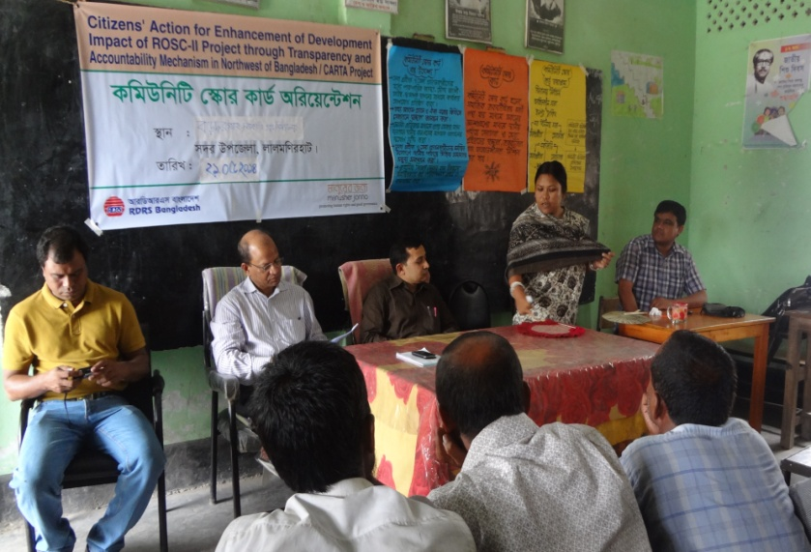

Input tracking was the second step of Community Score Card process. Input tracking is a process to list of LC resources and which resource is available for service receiver like books, Black board, pencil, Sharpener, sport materials etc. In that process input tracker find out which element are most valuable to provide quality of education. This group in that time, identifies that listed element receive which group like government of ROSC II. Sometimes they are tried to check that this LCs teacher maintained any register for these element. RDRS Bangladesh staff supported to 135 LCs under ROSC II project input tracking processes of the three upazila of CARTA project areas.

Under input Tracking Process following participant`s attended in the event:

|  |  |  |  |  |  |
| --- | --- | --- | --- | --- | --- |
| **Step** | **Event** | **Number of Input tracking** | **Male** | **Female** | **Total** |
| 2 | **Input Tracking in LC** | 135 | 399 | 816 | 1215 |

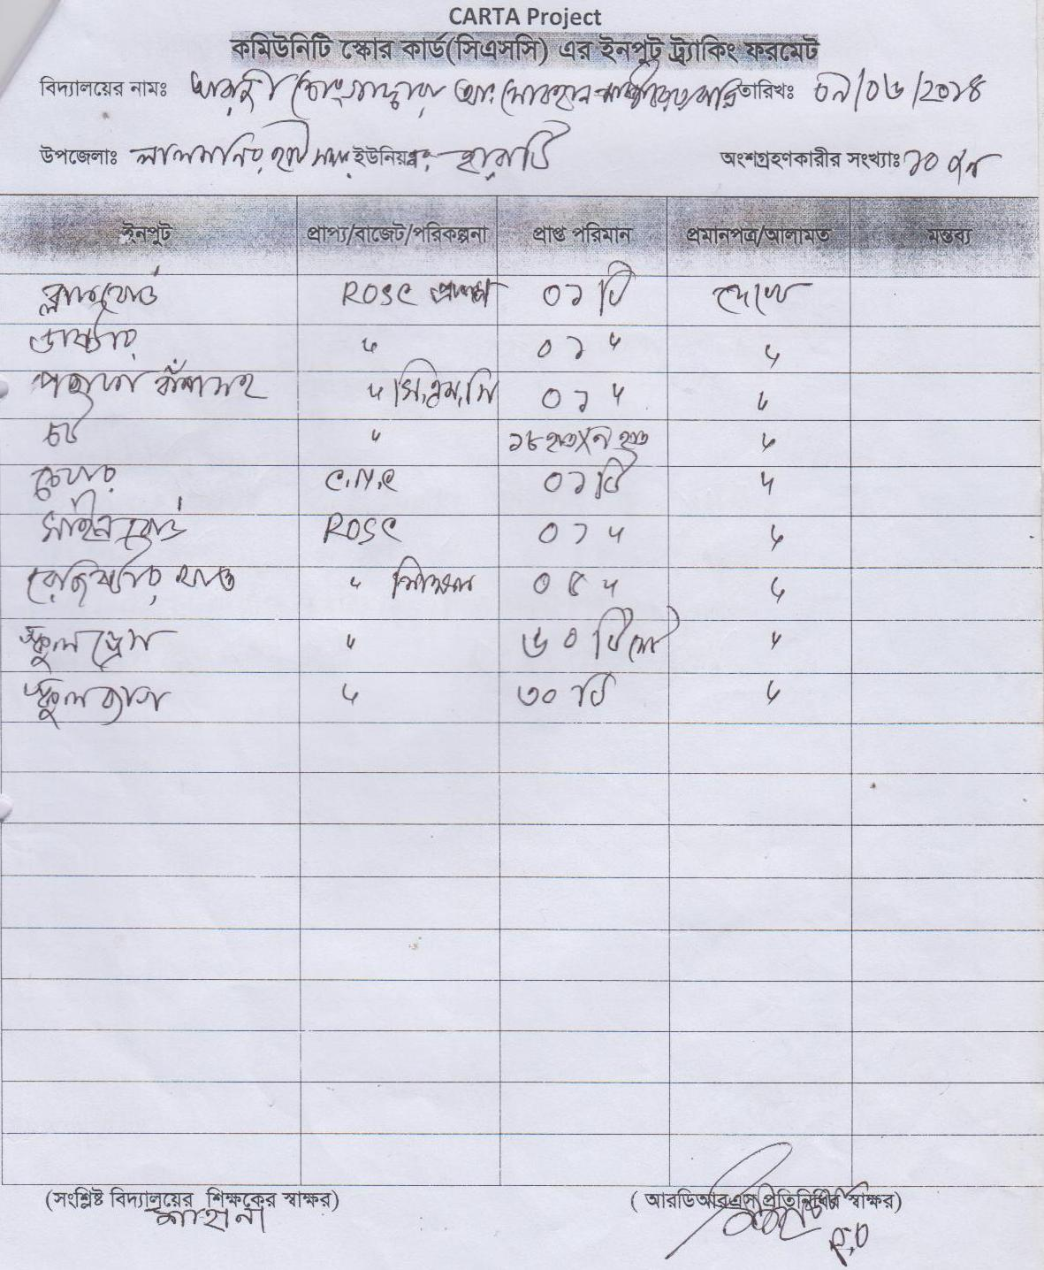**Input Tracking chart at LC**

**Step-3: Performance Score (FGD)**

Performance score (FGD) was third step of community score card process. In that step, at first, Staff of CSO was dividing between two part service receiver and service provider of attending participator. The participator selected 13 indicators in orientation meeting. After that two group sit-down different place and participated to FGD and gave score on the performance of teacher, CMC member, guardian, environment of LC etc. Staff of RDRS Bangladesh conducted 270 FGD in different LC in different time.

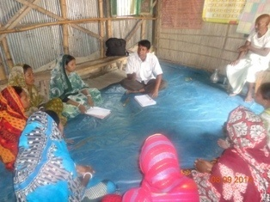 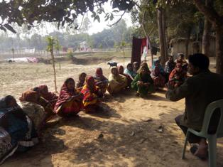

**As follow 13 indicators:**

|  |  |  |  |  |  |  |  |  |
| --- | --- | --- | --- | --- | --- | --- | --- | --- |
| **Step 3: Participant of FGD** | | | | | | | | |
| **Service Receiver** | | | | | **Service Provider** | | | |
| Number of FGD | Male | Female | Total | Remarks | Number of FGD | Male | Female | Remarks |
| 135 | 459 | 1556 | 2015 |  | **135** | **409** | **836** | **1245** |
| **Total Participant** | | | | | | | | **3260** |

**Step-4: Interface Meeting:**

At the forth step of community score card was to conduct both evaluation by the service providers and service receiver. During the FGD process both group gave score on the selected indicators different way. After the FGD process both group gathered same place and staff of RDRS Bangladesh discussed with group and community people about giving score. Staff of RDRS Bangladesh showed the FGD scoring with all participants and participator argument about giving score during that time. In that season these group discuss each other to go common understanding and minimize score and input number in the community score card. Staff of CSOs and participator prepared an action plan how to develop of LC over all environments with in time line. During that meeting all participant made monitoring group to monitor these action plan and some work to achieve goal CSC. Staff of RDRS Bangladesh discussed with monitoring group about their role and responsibility that how to monitor these action plan.

|  |  |  |  |  |
| --- | --- | --- | --- | --- |
| Step | Number of Interface Meeting | Male | Female | Total |
| 4 | 270 | 2005 | 8014 | 10019 |

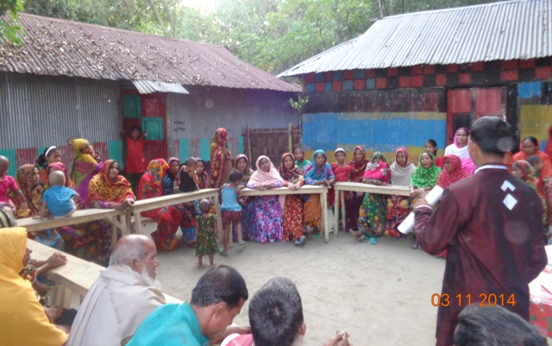

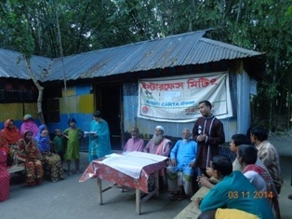**Score sheet of Community Score Card:**

**1st round Score of CSC :**

|  |  |  |  |  |  |
| --- | --- | --- | --- | --- | --- |
| **Name of Indicators** | **Community/ Service Receiver** | | **Service Provider/CMC** | | **Recommendation** |
| Score  (0-10) | Perception | Score  (0-10) | Perception |
| 1. Community involvement in the process of LC selection and establishment | 1.9 | Most of the community people (within the casement area) did not know about the process | 2.98 | Some of CMC member those who were involved as initiator | During establishment period of LC project should arrange a mass gathering/ community meeting |
| 2. Community involvement in CMC member selection and formation process | 1.44 | The formation of CMC Without concern guardian and community people | 2.77 | -CMC consist informal way  -Committee formed within the short time | -Should avoid over night CMC formation .  - Participatory process should be followed. |
| 3. Community involvement in children selection process /community awareness about student selection process | 2.6 | - Community people were not involved in student selection process  - Student list prepared by the Partner Organization | 2.8 | - Few of CMC member involved the student enrolment process  -Most of the CMC were not involved in children selection process | Community should be involved in children section process |
| 4. Are you know the criteria of children selection of Annonda school | 2.82 | Community are not informed about the criteria of children selection | 3.2 | Most of the CMC member unaware about the criteria of children selection | -CMC- Children selection criteria should be informed before listed the children  -Community- before list down the children Project arranged community meeting and disclosed the criteria |
| 5. Community awareness on project activity and purpose | 1.42 | Project was not taken initiative to inform the community | 2.42 | CMC member were not aware about the ROSC project activates through formal way | Project should be organized mass gathering for awareness raising on project activates and purpose |
| 6. community satisfaction on effectiveness and performance of CMC | 2.2 | CMC member ignored the community people | 3.2 | LC teacher and chairperson took most decision without meeting or sharing with other CMC member | Reformation of CMC to follow the election process |
| 7. Capacity building training received after selected CMC member | 00 | They did not know about the issue | 00 | We did not capacity building related support from the project | Need to training on role and responsibility of CMC for playing effective role to run the LCs |
| 8. Environmental condition of LC (Light, air, floor condition, room condition, sanitation facilities safe drinking water facilities etc.) | 3.4 | -Many of LC insufficient air and light  -Sanitation and safe drinking water facilities are not adequate | 4 | -Many of LC insufficient air and light  -House owner have sanitation and safe drinking water facilities but children feel discomfort to use | - LC should have Sanitation and safe drinking water facilities due to long run project  -Increase Community engagement and UP linkage for ensuring this kind of facilities |
| 9. Satisfaction level of stipend for children | 4 | - All student were not getting stipend  - Dress quality is poor | 5.1 | They were not involved in this process. | It should clearly inform to the community about project facilities |
| 10. How to informed regular CMC meeting decision making implementation by the CMC member | 2.1 | -Community people is not know about meeting decision making and implementation  - CMC meeting not conduct regularly  - Community people were not aware about role of CMC | 3.1 | -CMC member not attend in meeting regularly due to personal business  -Most of the CMC were not aware about their role . | -They required from the project  1. capacity building training  2. Proper guidance to manage the LCs activities  3. Need to disclose project related information |
| 11. Are you generally Satisfied with the activities of CMC | 2 | -CMC did not conduct regular meeting  -They have no role in children selection  - They do not visit LCs regularly  CMC has no role to improvement of LCs | 3.3 | -lack of capacity, cooperation , coordination among CMC members and understanding about the project  -Have no idea about CMC role and responsibility | Requested to Provide training for CMC and share the project facilities and activities for community people |
| 12. How to informed CMC Chairman selection process and level of satisfaction | 2.1 | -Community and guardian fully unknown the selection of CMC chairman  -CMC chairmen selected by LC teacher | 2.8 | CMC chair were not selected in participatory way | Need to practice participatory process for CMC formation |
| 13. Register update by the CMC member | 1.4 | -Community people not know the record keeping system | 1.9 | Not update regularly. | Provide training |

2nd round score of CSC:

|  |  |  |  |  |  |
| --- | --- | --- | --- | --- | --- |
| **Name of Indicators** | **Community/ Service Receiver** | | **Service Provider/CMC** | | **Recommendation** |
| Score  (0-10) | Perception | Score  (0-10) | Perception |
| 1.Cleanness of students | 8.0 | Cleanness of students is increases | 7.74 | Regular motive to students for ensuring cleanness | Should continue motivation process among parents and students |
| 2.Annual plan for LCs | 9.01 | Now we found displayed annuals | 9.07 | We have prepared annuals plan and displayed by the support of carta | Should continue that practice |
| 3.Quarterly progress report | 6.20 | This is new and found displayed at LCs | 6.52 | We have prepared annuals plan and displayed by the support of carta | Should continue that practice |
| 4.LCs visit by CMC and ESC | 7.55 | Now CMC are more active to visit LCs | 5.17 | Always inviting them to visit LCs and have found progress | This is a good job it should be gearing up. |
| 5.Communication between guardian and LCs | 7.34 | We always try to visit LCs and share progress with the teacher | 8 | We are trying to build a meaningful relation with the guardian after csc intervention | We will continue this approach for bringing better result |
| 6.Use of materials | 7.28 | Now teacher use some materials when teaching | 9.1 | I tried best use of existing materials and collection from mother school | Should be collecting materials from local resources as per needs. |
| 7.Regular meeting of CMC | 7.59 | Before the meeting CMC members are informed by LCs teacher, they try to conduct meeting regularly and execute the decision were taken | 8.73 | Now most of the CMC are playing active role\ Many CMC are more active to improve LCs conditions | Need to training on role and responsibility of CMC for playing effective role to run the LCs |
| 8.Presence and disappear of teacher | 9.3 | Now teacher come in LCs regular ,maintain time and inform us related matters | 9.06 | Now I am maintained to present and departure time and also inform CMC if I required leave. | Need to continue obey the LCs rules and lows. |
| 9.Sufficient light and air circulation | 8.71 | Community and CMC mobilized local resources and ensured some facilities | 7.97 | Community and CMC mobilized local resources and ensured some facilities | Need to Continue look after this issues. |
| 10.Safe water and sanitation | 6.98 | Now we found some progress in this indicator | 7.22 | We have ensured mostly same type of requirements | Increase Community engagement and UP linkage for ensuring this kind of facilities |

After successful implementation of CSC first round (April to June -2024), participants were developing an action plan for three month targeted with some useful indicator for LCs improvement. After that we have organized and facilitate second round (October to December-2014) of CSC based on the action plan through interface meeting and found some remarkable achievements. The second round score and

**Step 5: Institutionalization:**

Institutionalization was a fifth step of community score card process. In that process we institutionalized score card. We prepared community score card from fourth step after that this card we institutionalized in that step. Institutionalized score card hanging in LC that community people see these card easily. When community’s people see this card and who are identify present feature of LC. That is main objective of community score card. Which group or which stakeholder committed to work with CSC to develop over all environment of LC they name or group name was listed in that community score card. Others people easily known that who are listed to work for improvement of LC and which people are responsible for these work. Which group or people engaged with LC than there transparency and accountability of work showed by the CSC. Community’s people gave score on there all performance or activities in learning center. Community people committed each other by the CSC. Community score card is one kind of action plan. If community people work with CSC must be develop over all environment of LC.

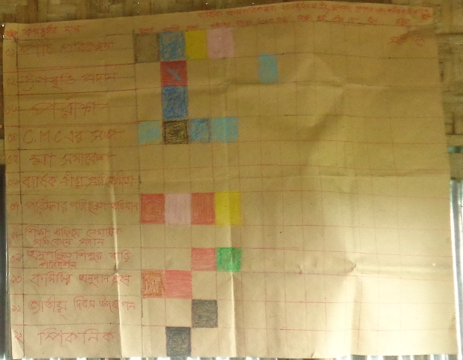 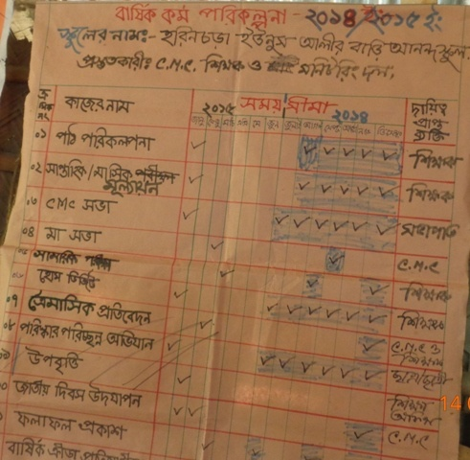 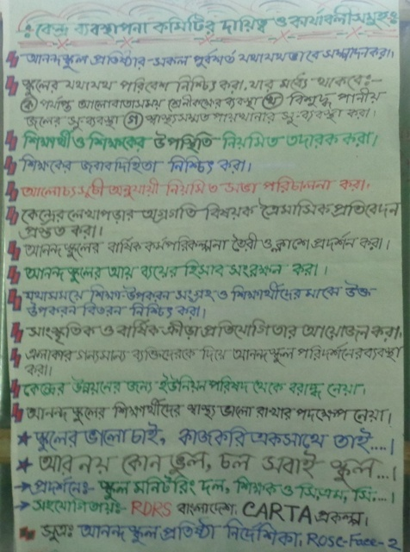

**Step 6: Follow up**

Follow up was a sixth step of community score card process. Staff of RDRS Bangladesh and community’s people made monitoring group from center management committee. Monitoring group was responsible for follow up community score card. Which group or people were committed to develop over all environments of LCs. Monitoring group observe there and suggest them to do work. Member of monitoring group they are engaged with center management committee due to this group is very effective for follow up CSC action plan.

**Developed Community Action Plan through interface meeting at LC of ROSC II**

|  |  |  |  |  |  |
| --- | --- | --- | --- | --- | --- |
| SL No | Activities Plan | Time Line | Suggestion | Responsible person | Follow up by |
| 1 | To organize regular meeting of CMC | Continue | Teacher of LC inform to CMC before 7 days at held meting and next meeting time will fix by the participatory way in this meeting. | 1. President of CMC 2. Teacher | Monitoring group |
| 2 | To available safe water and sanitation | July-August’14 | To available of existing resource and mobilize with local government and participation of community. | 1. CMC 2. Guardian 3. House owner | Monitoring group |
| 3 | To ensure sufficient light and air circulation | July ‘ 14 | To cut door and set up lighting tin sheet and if will possible than set up fan. | 1. CMC 2. Guardian 3. House owner 4. Local government | Monitoring group |
| 4 | To see presence and disappear of teacher | Continue | Follow the existing time schedule of ROSC II project. | 1. CMC 2. Guardian | Monitoring group |
| 5 | To increase communication between guardian and LC's | Continue | Conduct parents gathering, home visit and guardian look after to LC willingly. | 1. Teacher 2. CMC 3. Guardian | Monitoring group |
| 6 | LC's Visiting and Recommendation by CMC and Education Standing Committee (ESC) | Continue | To inform ESC about ROSC II and prepared them how to work in LC for further improvement | 1. Teacher 2. CMC 3. community | Monitoring group |
| 7 | To prepare annual and quarterly plan at LC's and institutionalization | July 14 | Starting year annual plan will be prepared and every after three month quarterly progress report prepared | 1. Teacher 2. CMC | Monitoring group |
| 8 | To ensure cleanness of the students | Continue | Improving all over environment of LC and aware to guardian about cleanness of student | 1. Teacher 2. CMC 3. Guardian | Monitoring group |
| 9 | To increase home visit of CMC | Continue | CMC visit these students home who are most of the time absence at LC | 1. Teacher 2. CMC | Monitoring group |
| 10 | To Increase Use of education materials | Continue | To develop education materials in LC by the local community, guardian and ROSC II support. | 1. Teacher 2. CMC 3. Guardian | Monitoring group |

**Changes after introduced of CSC:**

Remarkable community engagements were ensured after introduced social accountability tools/CSC. By the end of sub-project, there was a significant progress in community participation for LCs development. The changes performances of the Learning center that need more attention are as:

* Most of communities, parents and other stake holder now aware of goals, objective of ROSC-II and selection criteria of LCs. Through two time of CSC activity helped to message dissemination to the mass community and gained their positive response for LCs.
* Most of CMC member aware about their roles and responsibilities and CMC meeting is held regularly. During project period we have supported to organized 600 monthly CMC meeting and provide management training for potential CMC member.
* Linkage among Union parishad, Teacher, guardian & other stakeholder increased and stake holders perform their duties regularly. During project period we organized 27 union parishad standing committee meeting in favor of LCs linkage making and development.
* CMC visit increased to LCs after CARTA intervention at the same time all the community action plan were made for further improvements of LCs. With the cooperation of UP, community and CMC 17 LCs installed tube-well, 32 LCs setup sanitary latrine , 57 LCs ensured enough vitalization,
* Some LCs setup false ceiling to protect high temperature and some LCs enjoining ceiling fans in cooperation with community. Also the community and other counterpart continuing support to LCs for their sustainability.
* To expand creativity of students some LCs organized annual sports and picnic by the support of union parishad, community .This kind of events were organized first time in field that also created an example for necessity of community engagement.

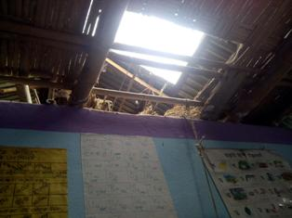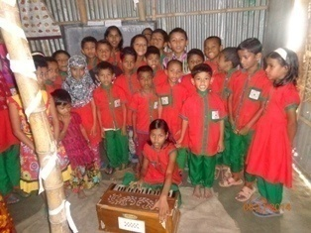

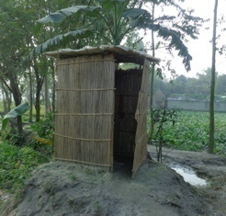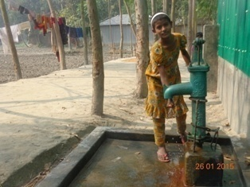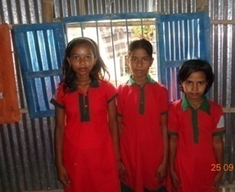

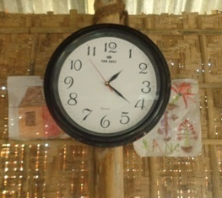

**Major Challenges of Community Score Card**

* It was tough to take proper opinion from them as they are illiterate.
* To score after tri discussion
* To hold working people for CSC activities
* Possibility of variance of opinion between Service provider and Service receiver
* Build up capacity of monitoring group to follow up CSC and
* To institutionalize community score card.

**Main conclusions and lessons learned**

The following conclusions and lessons can be drawn from the process of the CSC method for assessing performance of Anondo School:

**. .** CSC method is generally acceptable for application on ROSC-II and is suitable for assessing Learning Center in particular.

**. .** Quality of facilitation is among key preconditions for the success of CSC. For effective facilitation of the CSC process, it is not enough to introduce future facilitators to the method, rather training should envisage mastering of facilitation skills step-by-step in line with the stages of the CSC process. It is important that future facilitators learn the logic of each CSC stage and could see the difference between the goals and focus of each meeting organized in the framework of the assessment.

**. .** there is a space for optimization of the CSC method. In cases where conflict escalation capacity is low and providers and users easily reach understanding, the assessment can be carried out jointly by users and service providers and not separately. However, a decision on such optimization of the CSC method should be made on case by case basis and by an experienced facilitator.

**. .** CSC assessment method requires from a facilitator skills to reveal the existing problems and ask participants critical questions - a role that is for a local facilitator (who is a person integrated into the local social net) may be rather "inconvenient." In this case, it is necessary to take seriously the issue of facilitator selection and to consider an involvement of facilitators from community (but preferably from guardian).

**. .** Conduction of CSC at accelerated speed does not necessary promote the development of ownership of the process among the service users. For the method to be more enrooted locally, apart from adequate time reserved for preparation and work with the community, it also needs repeated experience of conducting CSC. The value of the CSC method can be realized by the community if it proves effective in terms of actual influencing of the improvement of services quality.

## List with place and dates of main project related to SA tools ( Community Score Card )

|  |  |  |  |  |  |
| --- | --- | --- | --- | --- | --- |
| **SL** | **Name of School / Place** | **Upazila** | **District** | **1st Round CSC**  **Date** | **2nd Round CSC**  **Date** |
| 1 | Radhanagar Dakkhin Khamarpara Anondo School | Badargonj | Rangpur | 18/05/2014 | 22/11/2014 |
| 2 | Radhanagar Noyapara Anondo School | 18/06/2014 | 22/11/2014 |
| 3 | Mowagas Dhodrarpar Anondo School | 17/06/2014 | 17/11/2014 |
| 4 | Radhanagar Mandol Para Anondo School | 23/06/2014 | 24/11/2014 |
| 5 | Lakkhonpur Khiarpara Anondo School | 23/06/2014 | 15/11/2014 |
| 6 | Gopinathpur Hasina Nagar Anondo School | 23/06/2014 | 16/11/2014 |
| 7 | Rahmatpur Hindu Para Anondo School | 25/06/2014 | 11/11/2014 |
| 8 | Chowrir Bil Anondo School | 22/06/2014 | 13/11/2014 |
| 9 | Taxerhat Balapara Anondo School | 17/06/2014 | 09/11/2014 |
| 10 | Dakkhin Moksudpur Mohila vice Chairman bari Anondo School | 30/06/2014 | 20/11/2014 |
| 11 | Talpukur Kumarpara Anondo School | 24/06/2014 | 16/11/2014 |
| 12 | Jharowarbil Poschimpara Anondo School | 29/05/2014 | 19/11/2014 |
| 13 | Moksudpur Hazipara Anondo School | 25/06/2014 | 08/11/2014 |
| 14 | Moksudpur Pramanik para Anondo School | 30/06/2014 | 17/11/2014 |
| 15 | Purba Jharowarbil Anondo School | 29/06/2014 | 19/11/2014 |
| 16 | Saatghoriya Polypara Anondo School | 22/06/2014 | 12/11/2014 |
| 17 | Barnirbazar Namapara Anondo School | 20/06/2014 | 10/11/2014 |
| 18 | Moddhokhoddo Bagbar Anondo School | 29/06/2014 | 09/11/2014 |
| 19 | Jamalpur Polypara Anondo School | 24/06/2014 | 25/11/2014 |
| 20 | Barobigha Anondo School | 22/06/2014 | 26/11/2014 |
| 21 | Indirapara Anondo School | 20/05/2014 | 27/11/2014 |
| 22 | Chalkpolashbari Sordarpara Anondo School | 21/05/2014 | 13/11/2014 |
| 23 | Modhupur Purbo Kazipara Anondo School | 22/05/2014 | 24/11/2014 |
| 26 | Kinbosontopur Anondo School | 25/06/2014 | 18/11/2014 |
| 27 | Dalalipara Anondo School | 25/5/2014 | 09/11/2014 |
| 24 | Moynakuri Baparipara Anondo School | 25/05/2014 | 10/11/2014 |
| 28 | Baghmararhat Guchchogram Anondo School | 24/06/2014 | 22/11/2014 |
| 29 | Rostomabad Hazipara Anondo School | 24/06/2014 | 22/11/2014 |
| 30 | Kutubpur Jummapara Anondo School | 25/06/2014 | 18/11/2014 |
| 31 | Kalupara Amlirdanga Anondo School | 01/06/2014 | 08/11/2014 |
| 32 | Boirampur Miyapara Anondo School | 03/06/2014 | 23/11/2014 |
| 33 | Chhoto Hazipur Anondo School | 05/05/2014 | 09/11/2014 |
| 34 | Bishnupur Purbopara Mojid Mastererbari Anondo School | 22/06/2014 | 12/11/2014 |
| 35 | Par Bishnupur digholtari Anondo School | 08/06/2014 | 17/11/2014 |
| 36 | Bujruk Hazipur Gachhuyapara Anondo School | 09/06/2014 | 06/11/2014 |
| 37 | Osmanpur Mollapara Anondo School | 24/06/2014 | 24/11/2014 |
| 38 | Kaliganj Mondolpara Anondo School | 24/06/2014 | 23/11/2014 |
| 39 | Ghrilai telipara Anondo School | 10/06/2014 | 13/11/2014 |
| 40 | Dolua Purbapara Anondo School | 11/06/2014 | 22/11/2014 |
| 41 | Dolua Poschimpara Anondo School | 23/06/2014 | 22/11/2014 |
| 42 | Osmanpur Khamarerdanga Anondo School | 18/06/2014 | 25/11/2014 |
| 43 | Osmanpur Sarkarpara Anondo School | 12/06/2014 | 06/11/2014 |
| 25 | Osmanpur Moddhopara Anondo School | 15/05/2014 | 20/11/2014 |
| 44 | Borohazipur Baniyapara Anondo School | 16/06/2014 | 08/11/2014 |
| 45 | Kamarpara Adivashi Anondo School | 17/06/2014 | 23/11/2014 |
| 46 | Vitorkuti Anondo School | Aditmari | Lalmonirhat | 08/06/2014 | 05/11/2014 |
| 47 | Gandhomarua Anondo School | 09/06/2014 | 06/11/2014 |
| 48 | Sotto Mongolkot Anondo School | 10/06/2014 | 04/11/2014 |
| 49 | Purba Digholtari Anondo School | 10/06/2014 | 10/11/2014 |
| 50 | Jigabari Raisa Maisa Anondo School | 19/06/2014 | 07/12/2014 |
| 51 | Pathanjhar Anondo School | 12/06/2014 | 20/11/2014 |
| 52 | Chanmiyar chatal Choukidarer bari Anondo School | 15/06/2014 | 04/12/2014 |
| 53 | Taluk Dulali Anondo School | 16/06/2014 | 02/12/2014 |
| 54 | Poschim Velabari Anondo School | 17/06/2014 | 03/12/2014 |
| 55 | Guchchagram Anondo School | 18/06/2014 | 08/12/2014 |
| 56 | Shankorpara Anondo School | 19/06/2014 | 22/11/2014 |
| 57 | Lal Gopal Burirdighi Anondo School | 25/06/2014 | 7/12/2014 |
| 58 | Madhobpara Anondo School | 26/06/2014 | 10/11/2014 |
| 59 | Horibola Anondo School | 29/06/2014 | 09/12/2014 |
| 60 | Moynarchoura Anondo School | 04/06/2014 | 23/11/2014 |
| 61 | Chandimari Anondo School | 30/06/20 14 | 03/11/2014 |
| 62 | Sobdol Anondo School | 04/06/2014 | 12/11/2014 |
| 63 | Musordoul Jor Anondo School | 16/06/2014 | 22/11/2014 |
| 64 | Sorolkha Anondo School | 23/06/2014 | 10/11/2014 |
| 65 | Taluk Horidas Chauratari Anondo School | 18/06/2014 | 23/11/2014 |
| 66 | Jagodish Baburtari Anondo School | 22/06/2014 | 09/11/2014 |
| 67 | Purbo Deiljor Anondo School | 05/06/2014 | 07/11/2014 |
| 68 | Charalbill Anondo School | 03/06/2014 | 05/11/2014 |
| 69 | Matherpar Anondo School | 19/06/2014 | 06/11/2014 |
| 70 | Tepatari Anondo School | 30/06/2014 | 11/11/2014 |
| 71 | Gilabari Anondo School | 09/06/2014 | 25/11/2014 |
| 72 | Jamurtari Anondo School | 26/06/2014 | 14/11/2014 |
| 73 | Shadhin Mastererbari Anondo School | 25/06/2014 | 02/11/2014 |
| 74 | Aditmari Badoler Chatal Anondo School | 23/06/2014 | 25/12/2014 |
| 75 | Ratherpar Anondo School | 02/06/2014 | 03/11/2014 |
| 76 | Kuthirpar Anondo School | 30/06/2014 | 20/11/2014 |
| 77 | Bosintari Anondo School | 17/06/2014 | 08/12/2014 |
| 78 | Kholahati Anondo School | 03/06/2014 | 24/11/2014 |
| 79 | Sofikul Islamerbari Anondo School | 09/06/2014 | 23/11/2014 |
| 80 | Deodoba Anondo School | 15/06/2014 | 09/11/2014 |
| 81 | Kisamat khudrochondro Anondo School | 16/06/2014 | 10/12/2014 |
| 82 | Sayed Ali Namuri Anondo School | 17/06/2014 | 24/12/2014 |
| 83 | Tondra Mohisha Sohor Anondo School | 01/06/2014 | 23/12/2014 |
| 84 | Dakurkhamar Anondo School | 18/06/2014 | 16/12/2014 |
| 85 | Kamarpara Anondo School | 18/06/2014 | 17/12/2014 |
| 86 | Chondimari Char Anondo School | 19/06/2014 | 11/12/2014 |
| 87 | Baroghoriya Anondo School | 22/06/2014 | 8/12/2014 |
| 88 | Mahbub Rahman Boyatirbari Anondo School | 05/06/2014 | 14/12/2014 |
| 89 | Rojobpara Anondo School | 24/06/2014 | 03/11/2014 |
| 90 | Alomgirerbari Anondo School | 01/06/2014 | 9/12/2014 |
| 91 | Fulgachh Sonardighi Jaliler Bari Anondo School | Sadar | 12/06/2014 | 23/11/2014 |
| 92 | Fulgachh Rail gate Mojnurbari Anondo School | 25/06/2014 | 19/11/2014 |
| 93 | Bumka Soymatha Anondo School | 17/06/2014 | 23/11/2014 |
| 94 | Kodalkhata Abdul Hamiderbari Anondo School | 28/06/2014 | 20/11/2014 |
| 95 | Dakkhin Kornopur Abdul Mojid Masterer Bari | 23/06/2014 | 17/11/2014 |
| 96 | Kornopur Bot tola Jahangir Alamerbari Anondo School | 18/06/2014 | 16/11/2014 |
| 97 | Char Shiber Kut Malekerbari Anondo School | 19/06/2014 | 12/11/2014 |
| 98 | Purba borua Modhu mongoler bari Anondo School | 19/06/2014 | 13/11/2014 |
| 99 | Meduarkuti Moktarer Bari Anondo School | 23/06/2014 | 15/11/2014 |
| 100 | Singadar Monchhur Alir bari Anondo School | 19/06/2014 | 05/11/2014 |
| 101 | Satpatki Suboler Bari Anondo School | 22/06/2014 | 10/11/2014 |
| 102 | Satpatki Burirdighi Asrayon prokolpo Anondo School | 26/06/2014 | 11/11/2014 |
| 103 | Kashipur Altaf Hossainerbari Anondo School | 17/06/2014 | 04/11/2014 |
| 104 | Arazichongadara Anondo School | 09/06/2014 | 17/11/2014 |
| 105 | Fakirtari Monjurbari Anondo School | 17/06/2014 | 03/11/2014 |
| 106 | Namuri Harati Amzad Hossainer Bari Anondo School | 16/06/2014 | 09/11/2014 |
| 107 | Kisamat Harati Jhakuatari Belalerbari Anondo School | 09/06/2014 | 15/11/2014 |
| 108 | Hiramanik Md. Sohidar Rahmaner Bari Anondo School | 15/06/2014 | 05/11/2014 |
| 109 | Namuri Harati Afsarer Bari Anondo School | 16/06/2014 | 09/11/2014 |
| 110 | Khuniagachh Hindutari Dinesh mastererbari Anondo School | 15/06/2014 | 05/11/2014 |
| 111 | Kalmati Anondo Mazhir Bari Anondo School | 19/06/2014 | 11/11/2014 |
| 112 | Horinchora Younis Alir bari Anondo School | 18/06/2014 | 06/11/2014 |
| 113 | Horinchora Albert membererbari Anondo School | 04/06/2014 | 12/11/2014 |
| 114 | Horinchora Khunigachh Joynalerbari Anondo School | 22/06/2014 | 10/11/2014 |
| 115 | Purba Horinchora Hazipara Shofirbari Anondo School | 16/06/2014 | 10/11/2014 |
| 116 | Chheknapara Umed Alir bari Anondo School | 15/06/2014 | 19/11/2014 |
| 117 | Razpur (Hudurbarzar) Altaf Hossainer Bari Anondo School | 15/06/2014 | 20/11/2014 |
| 118 | Kholaighat Balapara Bozlurbari Anondo School | 12/06/2014 | 13/11/2014 |
| 119 | Kholaighat Purbapara Rofikulerbari Anondo School | 12/06/2014 | 13/11/2014 |
| 120 | Kisamat Chenatoli Purbapara Jakirerbari Anondo School | 12/06/2014 | 16/11/2014 |
| 121 | Kholaighat Shamsulerbari Anondo School | 24/06/2014 | 18/11/2014 |
| 122 | Dhangga Abbaser Bari Anondo School | 24/06/2014 | 09/11/2014 |
| 123 | Poshcimdalalpara arshaduler bari anondo school | 23/06/2014 | 23/11/2014 |
| 124 | Batantari Mostofi Songlogno Anondo School | 22/06/2014 | 19/11/2014 |
| 125 | Bouddordoba Anondo School | 24/06/2014 | 17/11/2014 |
| 126 | Gokunda Miyapara Nur Haque Miyar bari Anondo school | 22/06/2014 | 19/11/2014 |
| 127 | Rotipur Mojibur Rahmaner Bari Anondo School | 23/06/2014 | 18/11/2014 |
| 128 | Ramram Mr. Nepal Chondrer Bari Anondo School | 15/06/2014 | 24/11/2014 |
| 129 | Khondikorpara Abdur Rouf Miyar Bari Anondo School | 16/06/2014 | 20/11/2014 |
| 130 | Horideb Md. Noor Hoodar bari Anondo School | 11/06/2014 | 24/11/2014 |
| 131 | Sindurmoti mrito Robindronath Royer Bari Anondo School | 15/06/2014 | 20/11/2014 |
| 132 | Joyhori Razurbari Anondo School | 29/06/2014 | 19/11/2014 |
| 133 | Khedabag Fakirpara Abdur Rahmanerbari Anondo School | 18/06/2014 | 09/11/2014 |
| 134 | Borobasuriya Dakkhintari Anondo School | 18/06/2014 | 11/11/2014 |
| 135 | Biddabagish Shahar Alirbari Anondo school | 17/06/2014 | 12/11/2014 |

## Survey questionnaire

Monusher Jonya Foundation - RDRS Survey

Third Party Monitoring

Survey on parent-student

Consent of respondent

I want to talk with you about MJF-RDRS Survey. Information given by you will use only for research purpose. Your identity and information as interviewee will not be disclosed. Are you agreeing to provide interview?

**1=Yes 2= No Signature of interviewee (with consent)**

**Section A: Household’s Address**

|  |  |  |  |  |
| --- | --- | --- | --- | --- |
| **House name of House hold** |  |  | **Village/Mouza** |  |
|  |  |  |  |  |
| **Union** |  |  | **Ward No** |  |
|  |  |  |  |  |
| **Member No** |  |  | **District** |  |
|  |  |  |  |  |
| **Location of house** |  | | | |

**Section B: Personal information of interviewee**

| **Sl No** | **Type of question** | **Information** | | | | | **Code** |
| --- | --- | --- | --- | --- | --- | --- | --- |
|  | **ID of Student of Ananda School:** |  | | | | | |
|  | **Name of respondent guardian :** |  | | | | | |
|  | **Father/Husband Name of respondent guardian :** |  | | | | | |
|  | **Is respondent head of household?** | **1 = Yes, 2 = No** | | | | |  |
|  | **Age (Year):** |  | | | | | |
|  | **Member of Household:** | **Total (Person)** |  | **Male** |  | **Female** |  |
|  | **Religion:** | 1= Islam 2= Hindu 3=Buddhist 4=Christian  5= Others .................... | | | | |  |
|  | **Sex:** | 1= Female 2= Man | | | | |  |

|  |  |  |  |  |  |  |
| --- | --- | --- | --- | --- | --- | --- |
| **Type of questionnaire Check by supervisor** | **Spot Check** | **1** | **Back Check** | **2** | **Questionnaire Check** | **3** |
| **Signature of Supervisor** |  | **Date** |  | |  |  |
| **Signature of RDRS officer** |  | **Date** |  | |  |  |
| **Signature of Respondent (With consent)** |  | **Date** |  | |  |  |
| **Mobile number of Respondent** |  | | | |  |  |

1. **Household related information**

|  |  |  |  |  |  |  |  |  |  |  |
| --- | --- | --- | --- | --- | --- | --- | --- | --- | --- | --- |
| **1.1** | **1.2** | | **1.3** | **1.4** | **1.5** | **1.6** | **1.7** | **1.8** | **1.9** | **1.10** |
| **Serial number of HH members**  (Give a[√] beside the respondent) | **Name of household members**  **(Start from HH Head)** | | **Age** | **Gender**  **1=Female**  **2= Male**  **3=Other** | **Marital status** | **Educational status** | **Profession** | **Religion** | **Anthropological identity** | **Physically challenged**  **(1=YES**  **2= No)** |
| 1 |  | |  |  |  |  |  |  |  |  |
| 2 |  | |  |  |  |  |  |  |  |  |
| 3 |  | |  |  |  |  |  |  |  |  |
| 4 |  | |  |  |  |  |  |  |  |  |
| 5 |  | |  |  |  |  |  |  |  |  |
| 6 |  | |  |  |  |  |  |  |  |  |
| 7 |  | |  |  |  |  |  |  |  |  |
| 8 |  | |  |  |  |  |  |  |  |  |
| 9 |  | |  |  |  |  |  |  |  |  |
| 10 |  | |  |  |  |  |  |  |  |  |
| 11 |  | |  |  |  |  |  |  |  |  |
| 12 |  | |  |  |  |  |  |  |  |  |
| **1.5 Marital Status** | | 1= Married 2= Never Married 3= Divorced/Separated 4= Widow 5= Other------------- | | | | | | | | |
| **1.5 Education Qualification** | | Years of schooling (Write number of classes have passed)  77= Illiterate 88= Can write/sign name only 99= Not having institutional education, but can read and write | | | | | | | | |
| **1.7 Profession** | | 1= Public service 2= Private/NGO service 3= Small business 4= Medium business 5=Large business 6=Lawyer 7= Doctor 8=Engineer 9= Teacher  10= Agriculture Farming 11=Day labor/Farm labour 12=Rickshaw puller/ Labor/ Transport worker 13=Fisherman/blacksmith/potter/wiver 14=Emigrant 15=Retired 16= Student 17=Unemployed 18=Housewife 19=Other .................. | | | | | | | | |
| **1.8 Religion** | | 1= Islam 2- Hindu 3=Buddhist 4=Christian 5= Other (Specify)--------------- | | | | | | | | |
| **1.9 Anthropological identity** | | 1= Bengali 2= Aborigin or ethnic community | | | | | | | | |

**Opinion of guardian about selection of Learning Center (Ananda School)**

1. **Is there any Ananda school established at your area?**

1= Yes 2=No 88= Unknown

1. **Do you know about the ANANDA SCHOOL establishment process?**

1= Yes 2=No 88= Don’t know 99=No reply

1. **If answer is Yes, who has/have selected the location of the ANANDA SCHOOL?**

1= Upazilla Executive Officer (UNO 2= Upazilla Education Officer (UEO)

2= Headmaster of local/mother primary school 4= Teacher of the ANANDA SCHOOL

5= Members of Center Management committee (CMC)

6= Others -----------------------------------88=Unknown

1. **Was your opinion taken in selection of the ANANDA SCHOOL?**

1= Yes 2=No 88= Don’t know 99=No reply

1. **Is there any well arrangement of drinking safe water for students of the ANANDA SCHOOL?**

**(By observation)**

1= Yes 2=No

1. **Is there any arrangement of healthy sanitation facility (toilets) for both male and female students of the ANANDA SCHOOL? (By observation)**

1= Yes 2=No

1. **If answer is No, how they meet up their sanitation need?**

1= Use toilet of other’s residence adjacent ANANDA SCHOOL

2= Toilet in open place

3= Other (Specify)---------

88=Unknown

1. **Is there any arrangement of sports for male/female students of the ANANDA SCHOOL?**

1= Yes 2=No

1. **Whether school teacher or President of the CMC is owner of the Building/House of ANANDA SCHOOL?**

1= Yes 2=No

1. **Are you satisfied with the establishment process of ANANDA SCHOOL?**

1= Yes 2=No 99= No reply

1. **If answer is NO, what are the reasons for dissatisfaction?**

**(May have multiple answers)**

1= Location of ANANDA SCHOOL has been selected following undue influence of CMC President/Member

2= Teacher of ANANDA SCHOOL has fixed the location considering her convenience

3= Absence of ambient environment (e.g. no sunlight)

4= Political influence/Conflict of interest

5= Other (Specify)-----------------

**Appointment of teacher for ANANDA SCHOOL and quality of education**

1. **Do you think that selection process of teacher for the ANANDA SCHOOL was right?**

1= Yes 2=No 88= Unknown 99= No reply

1. **Was the result of teacher recruitment exam disclosed?**

1= Yes 2=No 88= Unknown 99= No reply

1. **Whether teacher appointment process was done properly following the guideline/manual?**

1= Yes 2=No 88= Unknown 99= No reply

1. **If answer is NO, what types of irregularities took place?**

1= Corruption practiced in teacher appointment

2= Qualified teachers were not selected

3= Appointed teacher of more than 40 years of age

4= Relative of the CMC member was selected

5= Others (specify) ----------------------------------------

1. **Did you heard about providing training to teacher?**

1= Yes 2= No 88= Unknown

**Standard of Teacher & Education**

1. **Attitude/Behavior of teacher**

|  |  |  |  |  |  |  |
| --- | --- | --- | --- | --- | --- | --- |
| **18.1** | **18.2** | **18.3** | **18.4** | **18.5** | **18.6** | **18.6** |
| **SL No of HH member** | **Do all classes held regularly?** | **Does class teacher take all classes in time?** | **Is the teaching of class teacher satisfactory?** | **Have your child faced any corporal punishment by the teacher?** | **Does the teacher inform you about the study condition of your child?** | **Is the result published in due time?** |
| 1 = Most of the time  2 = Hardly  3 = Never | 1 = Most of the time  2 = Hardly  3 = Never | 1 = Yes  2 = No | 1 = Most of the time  2 = Hardly  3 = Never | 1 = Yes  2 = No | 1 = Most of the time  2 = Hardly  3 = Never |
|  |  |  |  |  |  |  |
|  |  |  |  |  |  |  |
|  |  |  |  |  |  |  |

1. **Does the teacher stay close to school?**

1= Yes 2= No 88= Unknown

1. **Does the teacher use educational materials regularly?**

1= Yes 2= No 88= Unknown

1. **Does any Upazila Education Officer visit/supervise the activities of ANANDA SCHOOL?**

1= Yes 2= No 88= Unknown

1. **Whether the CMC members enquire into the standard of your child education?**

1= Yes 2= No 88= Unknown

1. **Do the implementing NGO monitor the standard of education in the ANANDA SCHOOL?**

1= Yes 2= No 88= Unknown

1. **Does your child get standard education from the ANANDA SCHOOL?**

1= Yes 2= No 88= Unknown

1. **Do you know any student of the ANANDA SCHOOL gets scope to be admitted to primary school after completing study?**

1= Yes 2= No 88= Unknown

1. **Are the incentives of ANANDA SCHOOL hampering education in terms of enrolment in the local primary school?**

1= Yes 2= No 88= Unknown

1. **Are the incentives provided by the ANANDA SCHOOL better than primary school offer?**

1= Yes 2= No 88= Unknown

**Student selection process and education support program**

1. **Does the ANANDA SCHOOL admit more than 35 student?**

1= Yes 2= No 88= Unknown v

1. **Do you know the rule/condition for admission into ANANDA SCHOOL?**

1= Yes 2=No 88= Unknown

1. **In your opinion, can any child under 8 years get scope of being enrolled in ANANDA SCHOOL?**

1= Yes 2=No 88= Unknown 99= No reply

1. **Are your child being enrolled in the same class from which he/she dropped out/finished?**

1= Yes 2=No

1. **If not, why enrolled in lower grade?**

Ans:----------------------------------------------------------------------------------

1. **How long your child will study in ANANDA SCHOOL?-----------Year**
2. **Did your child ever enroll in the primary school?**

1= Yes 2=No 88= Unknown 99= No reply

1. **Who prepared the list of drop-out children?**

1= Implementing NGO 2= Primary school teacher 3= Teacher of the ANANDA SCHOOL

4= Committee (CMC) of ANANDA SCHOOL/Local guardian 5= Others (Write down)-----------88= Unknown

1. **Do you think student selection process of the school were correct?**

1= Yes 2=No 88= Unknown 99= No reply

1. **If NO, what are the reasons?**

1. -----------------------------------------

2. -----------------------------------------

1. **Does anyone get any undue favour for admission if CMC member is being relative?**

1= Yes 2=No 88= Unknown 99= No reply

1. **Does anyone get any undue favour for admission if member/UP chairman is being relative?**

1= Yes 2=No 88= Unknown 99= No reply

1. **Does the child from poor/disadvantage family get chance for admission in ANANDA SCHOOL?**

1= Yes 2=No 88= Unknown

1. **Do you know allocation amount for running the school/project?**

1= Yes 2=No 88= Unknown

1. **What are the supports provided for running ANANDA SCHOOL activities?**

**(May have multiple answers)**

1= Uniform/dress

2= Black board

3= Expense of educational materials including writing pad/sheets

4= Monthly study allowance

5= Teachers honorarium

6= School repairmen cost

7= Other (Write down)

88= Unknown

1. **Have your child got above mentioned educational materials?**

1= Yes 2=No 88= Unknown

1. **Did your child enrolled in the ANANDA SCHOOL to get monthly stipend?**

1= Yes 2=No 99= No reply

1. **Does your child get monthly stipend regularly?**

1= Yes 2=No 88= Unknown

1. **Have you identified any irregularity in accessing monthly stipend?**

1= Yes 2=No 88= Unknown

1. **If answer is yes, what kind of irregularity you have observed?**

**(May have multiple answers)**

1=Actual child of poor and destitute family did not get stipend

2= Nepotism or political/local influence in selection of stipend-holder

3= Money deducted as commission from the monthly stipend

4= Others (specify)-----------------------------------------------------

1. **Did they deduct any amount for exam fee or others without receipt?**

1= Yes 2=No 88= Unknown

1. **What do you prefer for education of your child?**

1= ANANDA SCHOOL 2= **Primary school**

1. **What measure you took for your child’s education in absence of ANANDA SCHOOL?**

Ans:----------------------------------------------------------------------------------

1. **Are you satisfied with the existing facilities from ANANDA SCHOOL?**

1= Yes 2=No 88= Unknown v

**Formation of CMC and Transparency and Accountability in its activities**

1. **Was any CMC for ANANDA SCHOOL in your area formed?**

1= Yes 2=No 88= Unknown

1. **Are you aware of eligibility criteria of CMC member?**

1= Yes 2=No 88= Unknown

1. **Was any election held for CMC?**

1= Yes 2=No 88= Unknown

1. **Did they select any member from poor family in the CMC?**

1= Yes 2=No 88= Unknown

1. **Was your opinion taken to form the CMC?**

1= Yes 2=No 88= Unknown

1. **Any unethical practice like political influence you have observed?**

1= Yes 2=No 88= Unknown 99= No reply

1. **Following which relationship applicable for the student of ANANDA SCHOOL with the selected Chairman of CMC?**

1= Mother 2=Father 3= Legal guardian 4= Not Legal guardian

1. **Are you satisfied with the CMC election process?**

1= Yes 2=No

1. **Whether any training/capacity development of CMC was provided?**

1= Yes 2=No 88= Unknown

1. **Does the CMC disclose its activities regularly?**

1= Yes 2=No 88= Unknown

1. **Did CMC prepare annual plan?**

1= Yes 2=No 88= Unknown

1. **Does the CMC monitor the attendance of student and teachers?**

1= Yes 2=No 88= Unknown

1. **Does the CMC ensure the accountability of teachers?**

1= Yes 2=No 88= Unknown

1. **Did CMC disclose income expenditure report of the committee?**

1= Yes 2=No 88= Unknown

1. **Did CMC inform about standard of education to guardian and public regularly?**

1= Yes 2=No 88= Unknown

1. **Did CMC take initiative to arrange cultural and sports program?**

1= Yes 2=No 88= Unknown

1. **Did CMC arrange visit of local elites to ANANDA SCHOOL?**

1= Yes 2=No 88= Unknown

1. **Does CMC meet regularly?**

1= Yes 2=No 88= Unknown

1. **Are you member of the CMC?**

1= Yes 2=No >> Que 75

1. **If yes, is there any scope to provide opinion in the meeting?**

1= Yes 2=No 88= Unknown

1. **Is your opinion discussed with importance?**

1= Yes 2=No 88= Unknown

1. **Are the decision regularly adopted in the general meeting?**

1= Yes 2=No 88= Unknown

1. **Are you satisfied with the activities of CMC?**

1= Yes 2=No 99= No reply

1. **What you suggest to improve the efficiency of CMC?**

**1. --------------------------------------------**

**2. ---------------------------------------------**

**Complaint Redress Mechanisms**

1. **Is there any system to receive any complaint regarding the standard of education or others affairs?**

1= Yes 2=No 88= Unknown

1. **Does implementing NGO redress any complaint lodged or submitted regarding quality of education or ANANDA SCHOOL management?**

1= Yes 2=No 88= Unknown

1. **Does CMC solve/address any complain?**

1= Yes 2=No 88= Unknown

1. **Do you think complain redress mechanism should be easier?**

1= Yes 2=No 88= Unknown

**Information on income and expenditures of households**

1. **Monthly expenses of household (In Tk.)**

|  |  |  |
| --- | --- | --- |
| Serial No. | Expense types | Overall expenses (In Tk.) |
| 1. | Food |  |
| 2. | House rents |  |
| 3. | Education |  |
| 4. | Medication |  |
| 5. | Other (Please specify)_________ |  |
| 6. | Other (Please specify)_________ |  |
| Overall= | |  |

1. **Monthly income of all member of household (In Tk.)**

| Serial No. | Sources of income | Overall income (In Tk.) |
| --- | --- | --- |
| 1. | Agricultural product/corns |  |
| 2. | Fishery, Poultry and animal rearing |  |
| 3. | Service/Day labourer |  |
| 4. | Business |  |
| 5. | Remittance from foreign countries |  |
| 6. | Remittance from within the country |  |
| 7. | Other (Please specify)_________ |  |
| Overall= | |  |

1. **Types of residence at which respondent’s household live (**Put a tick mark on right answer through direct observation**)**

Answer. 1= Full pucca house 2=Residential flat 3= Pucca wall and tinshed

4= Tin made house with tin shed 5= Mad wall and tin shed

6= Shan/fence/mud house 7= Other (Please specify)_________

1. **Household’s asset related Information**

| **Sl. No.** | **List of own assets** | **Quantity** | **Quantity Code**  **1= Decimal**  **2= Number** | **Total approximate value of all assets (In Tk.)** |
| --- | --- | --- | --- | --- |
|  |  |  |  |  |
|  |  |  |  |  |
|  | Cultivavable land |  |  |  |
|  | Resdiet house |  |  |  |
|  | Pond |  |  |  |
|  | Paddy/Rice (Aman) |  |  |  |
|  | Cattle/buffelo |  |  |  |
|  | Goat |  |  |  |
|  | Chicken and duck |  |  |  |
|  | Tractor/Agriculture equipment |  |  |  |
|  | Shallow tube well |  |  |  |
|  | Boat |  |  |  |
|  | Rickshaw/Van |  |  |  |
|  | Bi-cycle |  |  |  |
|  | Motor cycle |  |  |  |
|  | Large tree |  |  |  |
|  | CD player |  |  |  |
|  | TV |  |  |  |
|  | Cell phone/ Land phone |  |  |  |
|  | Preservation of paddy/rice/wheat/atta |  |  |  |
|  | Engine boat |  |  |  |
|  | Ornaments |  |  |  |
|  | Sanitary/Ring/Toilet |  |  |  |
|  | Other (Please specify)_________ |  |  |  |
|  | Other (Please specify)_________ |  |  |  |

Declare of enumerator

I would like to declare that all the Information gathered in this questionnaire are true and correct; those are collected from the respondent as per guideline. I have left the respondent after adequate crosscheck of the questionnaire encountered.

Name and signature of the respondent: ..........................................................

Date of Information collection: ..........................................................

## Case study 1

Community; Contributed a Ceiling fan for Learning Center (LC)

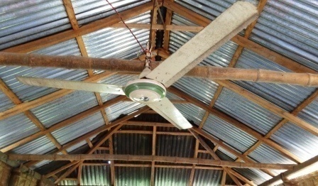Khiarpara Anondo School Situated at Lakhonpur village of Gopinathpur union under Badargonj upazila of Rangpur district. This School has established in 2013 by the ROSC-II project and total student is 33. According to LC implementing guideline, there is a Center Management Committee (CMC) in this school and the CMC will call a meeting every month but actually CMC committee was not active from the established period. Moreover, teaching learning procedure was interrupted due to lack of awareness ofguardian, friendly environment, infrastructure and regularity of children at LC etc.

RDRS Bangladesh is implementing Third Party Monitoring (TPM) under the CARTA project in these areas during 2014. To ensure transparency and accountability of ROSC II project, CARTA activities has raised awareness, developed communication, and increased participation at LC. The Community Score Card (CSC) is an important tool of CARTA project to develop learning center (LC). From the establish period of CSC the community people identified some indicators to develop the LC within time frame and The staff of RDRS Bangladesh have provided the technical support. Some mentionable indicator of all indicators is hygienic latrine, drinking water, light & air and report preparing.

Education Advisor of CMC of Khiar Para Anondo School Mr MD Jahurul Haque Said, ***“Without these indicators we cannot establish role model school. So we have to set up the indicator in our learning center.”*** All participants agreed with him. The participant of CSC meeting has committed to set up these indicators respectively. After that, stakeholder of this LC provided a ceiling fan. As a result teacher and guardian are happy. Md. Habibur Rahman, Student of Khiar Para Anondo School said, ***“We are not attending school regularly due to overheating. After set up ceiling fan we come to school regularly and enjoying the class very much.”***

## Case study 2

**Sanitary Latrine set up, tube well renovation and plinth raised at Learning Centre (LC)**

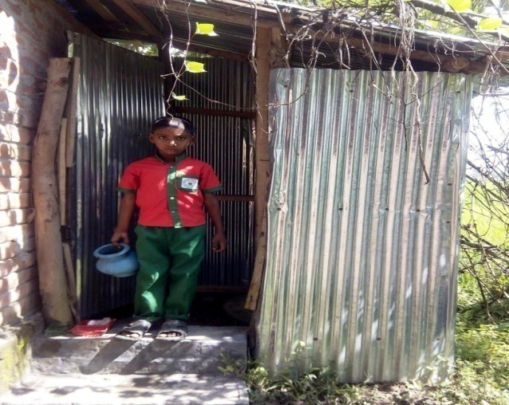The name of the Anondo School is Moynar Chawra at Komlabari, Aditmari, Lalmonirhat. The School was situated at low land, so in the rainy days it has been drowned under water 2/3 days. Moreover, it has no sanitary latrine. Student of this LC faced problem with it. Regularity of the student decrease day after day due to the helpless situation of the LC. There was a tube well surrounding at LC provided by the local government but it also drowned under water. For this student did not want to drink it and for drinking water they used to go far from the LC and caused decrease of regular student.

CARTA project implemented by RDRS Bangladesh has performed CSC interface meeting at the LC with predefined indicator. After that Stakeholder of surrounding LC set up the sanitary latrine, raised the plinth of the LC as well as renovated the tube well last 23/06/2014. As a result, Helpless situation has been changed and student is now very much interested to come school regularly. Furthermore, now they can drink the water of surrounding tube well as well as use the sanitary latrine when there is a need.

Mr. Dinesh Chandra, teacher of the Moynar Chawra School said, ***“I compel to leave the student who need to use latrine before, but now I am happy to see that I do not have to leave any student because we have sanitary latrine for the student and they can use it.”***

## Case study 3

**Tube well installed at Learning Centre in cooperation with the Union Parishad**

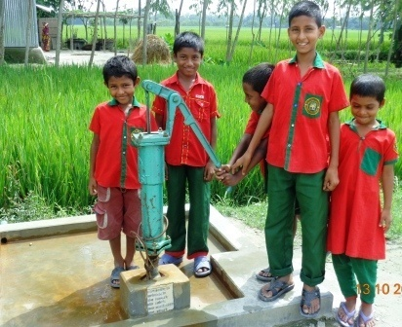**C**ARTA project implemented by RDRS Bangladesh completed the CSC interface meeting at Horin Chora Younis Alir Bari Anondo School at Khuniya gass, Lalmonirhat Sadar, Lalmonirhat. There is eighteen predefined indicator have discussed in the meeting. Two indicators such as safe drinking water and sanitary latrine has taken seriously to resolve because in the LC, there was no tube well and sanitary latrine to use for the children. UP member give assurance to resolve the problem in the interface meeting.

After that, CMC member and parents of students continuously communicate with the Union parishad member to arrange a tube well and sanitary latrine. Few days later, in the date of 23/06/2014, Md. Abdul Hakim, Union Parishad member presented at LC with a tube well, He then installed the tube well at his presence. At present 4/5 family along with the student of LC is drinking the water and using it for them. LC surrounding Community and CMC member expressed their happiness to get the tube well for the student. The suffering for the safe water and sanitary latrine has been removed from this LC. Student now do not need to go nearby houses to drink water, they can drink water of their own tube well.

Teacher of the LC and CMC member said, ***“We did not have the tube well if CARTA implemented by RDRS Bangladesh did not show the way.”*** Md. Abdul Hakim, union parishad member said, ***“The tube well platform will be constructed within next one week and 5 rings with 1 slab will be given in this school.”***

## Case study 4

**Annual picnic held in Aragee Chongadara Learning Center**

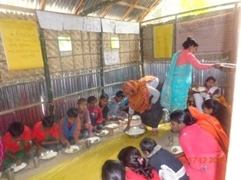Arajee Chongadara Anondo school situated majee para the village of Arajee Chondara Harati Union under Lalmonirhat sadar upazila districts of Lalmonirhat. By the demand of community people establish were a Anondo school in 2013 under ROSC –II project same as Aragee Chongdanga Learning School is one of them the school its consist of 35 students those are backward and out-of-school children and they will back in main streaming of the education . This school functions by the Center Management Committee.

Main responsibility of Center Management Committee to look after the learning Center and Community Monitoring Group always try out the focus the improvement of LC. As a part of non indicative activity community monitoring group and UP joint collaboration arrange annual picnic held on the date of 20 November 2014 in the yard of Aragee Cgongadara Learning center for the purpose get together , refresher, recreation and inspire the student . Picnic decision taken the meeting of Community score card interface Monitoring Group,s which held in 23 June 2014 and recorded the regulation . Over all carryout the responsibility Community Monitoring Group, LC teacher and technical assistance by Programme Organizer. On the occasion chief guest training Coordinator ROSC – II Lalmonirhat and education standing committee member Harhati UP are participate . Children are arrange different shorts of activity such as cultural function role play and song .

The speech of chief guest children needed recreation through learning by showing which is implication ,reflection and applicable to others Learning center improvement . Union parishad assurance that the help from UP the continuity of learning center improvement hope that the student of Anondo school they will prosper in life and back in the main streaming of the education and contribute to the society.

Learning center teacher Mrs. Sahana begum said all of my student was very happy to attend such kind of activity. Firstly my thanks to RDRS Bangladesh /CARTA project who give scope to community engagement and gear-up my CMC.

## Case study 5

**Community Contribution Annual Sports in Union Parishad campus**

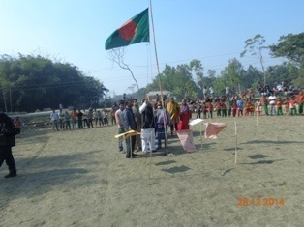

ROSC-II Learning center student Amena said that during my study life I never enjoy such kind of event; I am very much pleasure to perform my dance at annual sport and also glad when thousands of people were claps to me.

After Successful implementation social accountability tools of Community Score Card (CSC) activity a well linkage were established between Community monitoring group (CMG) and union parishd.As result CMG and union parishad jointly organize annual sports for six LCs student at union parish premises .Total six LCs is run at Harati union catchment under Lalmonirhat sadar upazilla. Lalmonirhat Sador Upazila consist of 9 union . Harhati union parishad is one of them.

The initiative of center management committee linkage with the Union parishad standing committee to arrange annual sports . This issue raise in Union Parishad monthly meeting and Union parished decided to contribute 5000/= TK for the Anondo school annual sports and community contribution add with the money to purchase prize .

Before there is no occasion held in Harati . This is the first time the disadvantage, socially excluded and floated student are participate the annual sports . For their refreshment , recreation, inspiration and enhancement of the student to arrange annual sports .The area of Harati UP 6 Anondo schools near about 210 students participate in annual sports on the date of 28 December 2014 in the place of Harati Union Parishad compound . There are different type events arrange for annual sports such as race , Dance, Song and Role play .Near about 2000 community people and students guardian observed annual sports and change the mentality of students .

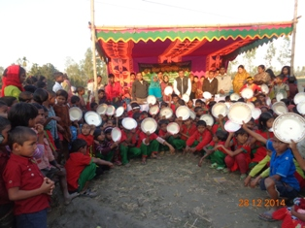Harati Union Parishad Chairman ( Chief guest ) , UP members , standing committee members , Journalist , CMC , RDRS Bangladesh representative and CMG members are presence to the prize distribution ceremony . 81 number of prize distribute to the winner of the events . Mr. K M Serazul Islam chief guest the occasion said that this support will be continue in future from the union Parishad and community, LC teacher should to improve the service and environment for Anondo school . Day by day the student of Anondo School prosper in life and socially contribute to develop the country

## Report On Learning Centre (LC) Management Training

Introduction

RDRS Bangladesh is implementing different kinds of project for developing the hard core poor people of northwest of Bangladesh. In this regard, Citizens’ Action for Enhancement of Development Impact of ROSC-II Project through Transparency and Accountability Mechanism in Northwest of Bangladesh / CARTA Project is being implemented. CMC training is one of the activities of CARTA project so CMC training is organized and funded by Manusher Jonno Foundation (MJF) with a view to play vital role for running the school through appropriate management and ensuring transparency as well accountability. There were 133 members from 135 CMC take training under 4 batches (2 days) at RDRS training unit in Lalmonirhat and Rangpur.

Participants are performing a group exercise

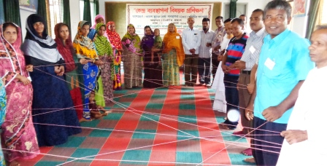

**Objective of the Training**

After successful training completion participant will have the ability of function with clear concept about management of Anondo School and they will be seeking the Centre more effective.

**Discussed Topic**

* Anondo School ( circumstances, Objectives, Structure, Management process)
* Management ( Conceptualization, Objectives, Kinds, Step)
* Formation of Central Management committee of Anondo School and Selection of the Student
* Duties and Activities of Central Management Committee
* Good Governance ( Concept, Objectives, Characteristic, Obstacle)
* Recommendations to strengthen Central Management Committee

**Methodology of the Training**

* Participatory Discussions
* Group Discussions
* Questions and Answers Session
* Open Thinking

**Use of the materials of the training**

* Operation manual of Anondo School
* Multi media
* Board Marker
* Poster paper
* Hand out

**Participant**

CMC members of Anondo School of ROSC II project

**Kinds of Participant**

Guardian, Teacher, UP member and education personnel

**Number of Participant**

|  |  |  |  |  |  |  |
| --- | --- | --- | --- | --- | --- | --- |
| **Batch NO** | **Place** | **Date** | **Male** | **Female** | **Total** | **Remarks** |
| **01** | Lalmonirhat | 13-14/8/14 | 29 | 06 | 35 |  |
| **02** | Lalmonirhat | 24/25/8/14 | 17 | 17 | 34 |  |
| **03** | Lalmonirhat | 26-27/8/14 | 19 | 16 | 35 |  |
| **04** | Rangpur | 10-11/9/14 | 24 | 05 | 29 |  |
| **Total** | | | 89 | 44 | 133 |  |

**Participant expectation**

* About Central Management Committee
* About Anondo School
* About Formation of CMS
* About Duties and Activities of Central Management Committee
* About Naming process of Anondo School
* About CARTA Project

**Recommendation of the participant**

* Organize CMC training at the starting of the project.
* Allocation/Donation will be made by Union parishad
* Snacks for CMC meeting
* Enhancement of teacher’s salary
* Organize bi monthly meeting at union level with CMC member

**Strength of the training**

* Spontaneous Participation of the participant
* Curiosity to learn something new
* Fantastic Discussion
* Showing Operational manual of anondo school After discussion of training content
* Presentation of Training Budget

**Limitations**

* There was no opportunity to organize training for all CMC Member.
* Training period is diminutive to get full concept about centre management.

**Assessment**

In this course, CMC roles and responsibilities of respective person is discussed which will give them assistance to play vital role for functioning the Anondo School. For this, they will seek for the center even more effective. We hope, they got the opportunity through the experience of the training methodologically which will help them to play important role for functioning the center. And objectives of the ROSC II project will be achieved.

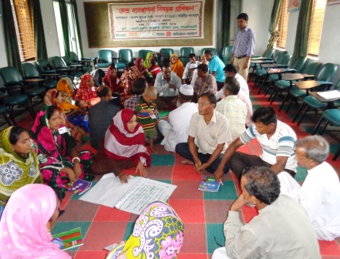

**Participants making recommendation**

**Conclusion**

It is important to increase social awareness with professional skill. Conscious people can extend quality education. For this, there is no other way except training to increase practical knowledge, skill, management and positive attitude in professional life. It has been produced the clear concept about CMC to the participant, on the other hand we hope there will be a successful ending of the ROSC II project objectives if they could apply the experience of this particular training in real.

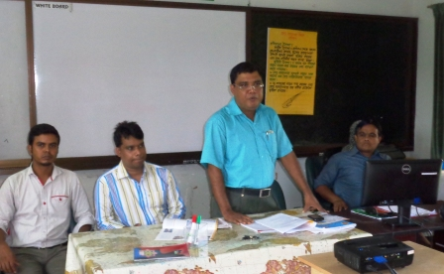

Md. Safikul Alam, AUEO of Lalmonirhat sadar briefing among the participant

1. The ROSC-II project is a follow on project to continue the work in ROSC-I
2. To hire a consultant for this survey, RDRS Bangladesh circulated an advertisement at [www.bdjobs.com](http://www.bdjobs.com) . After an open-bid process, Mr.Zakir Hossain Khan & associate were finally selected.
3. The respondents size have been calculated following formula for large sample size: n=t² x p(1-p) m²: Where, **n** = required sample size, **t =** confidence level at 95% (standard value of 1.96), **p =** For each question, since we don’t know exactly the response we have assumed the value at 50%, which gives the largest sample size, **m =** margin of error at 5% (standard value of 0.05). Estimated sample size would be determined for CARTA survey = 345 Parents
4. Both the service provider and receiver self-evaluations were quite low on this point. The average score provided by service receiver was 2.6, and by service provider: 2. 8 (out of 10).
5. Overall, the satisfaction levels with CMC performances were very poor. (Average score provided by service receiver 2.2, and by service provider-3.2 (out of 10).).